SUBCOURSE EDITION
FA8160 B

US ARMY FIELD ARTILLERY SCHOOL

FIELD ARTILLERY FIRE PLANNING
FOR OFFENSIVE AND DEFENSIVE
OPERATIONS

FIRE SUPPORT OFFICER/FIRE SUPPORT NONCOMMISSIONED OFFICER
MOS 13E MQS II

Author: Major Randy C. Barker, ATSF-TF, AV 639-5801/3688, Commercial (405) 351-5801

FIELD ARTILLERY FIRE PLANNING FOR
OFFENSIVE AND DEFENSIVE OPERATIONS

SUBCOURSE FA8160

US Army Field Artillery School
Fort Sill, Oklahoma

Six Credit Hours

GENERAL

This subcourse is designed to introduce the student to the general aspects of field artillery fire planning for offensive and defensive operations. It is presented in two lessons, each lesson providing information that supports the tasks listed below. These objectives serve as background knowledge that will help the student in future subcourses.

LESSON 1: Offensive Fire Planning

TASK NO: 01-2840.00-2032

TASK: Recommend the employment of fire support in offensive operations.

CONDITIONS: Given an offensive tactical scenario

STANDARDS: Recommend the employment of fire support in an offensive operation IAW procedures described in FM 6-20-30, FM 6-20-40, and FM 6-20-50.

TASK NO: 01-2840.00-2031

TASK: Explain the field artillery fire planning process.

CONDITIONS: Given a tactical situation

STANDARDS: Explain the field artillery fire planning process IAW FM 6-20-30, FM 6-20-40, and FM 6-20-50.

LESSON 2: Defensive Fire Planning

TASK NO: 01-2840.00-2033

TASK: Recommend the employment of fire support in defensive operations.

CONDITIONS: Given a tactical scenario

STANDARDS: Recommend the employment of fire support in defensive operations IAW FM 6-20-30, FM 6-20-40, and FM 6-20-50.

TABLE OF CONTENTS

Section Page

TITLE PAGE i
TABLE OF CONTENTS iii
ADMINISTRATIVE INSTRUCTIONS v
GRADING AND CERTIFICATION INSTRUCTIONS vi
Lesson 1: Offensive Fire Planning
Introduction 1
Framework 2
Offensive Fire Support 2
Allocation of Fire Support Assets 2
Offensive Fire Support Considerations for the Main Attack 5
Offensive Fire Support Considerations for Reserve Operations 13
Offensive Fire Support Considerations for Reconnaissance and
Security Operations 15
Offensive Fire Support Considerations for Deep Operations 19
Offensive Fire Support Considerations for Rear Operations 24
Offensive Fire Support Considerations for the Exploitation 32
Offensive Fire Support Considerations for the Pursuit 34
Field Artillery Position Selection and Displacement 36
Ammunition Management 38
Summary 48
Lesson 2: Defensive Fire Planning
Introduction 49
Framework 49

Section Page

Security Forces Forward and to the Flanks of the Defensive
Force 51
Main Battle Area Defensive Fire Support Planning 56
Deep Battle Area Defensive Fire Support Planning 60
Reserve Operations Fire Support Planning 61
Rear Area Defensive Fire Support Planning 63
Field Artillery Position Selection and Displacement 64
Ammunition Management 65
Summary 71

ADMINISTRATIVE INSTRUCTIONS

Subcourse content. This subcourse consists of two lessons. Each lesson presents background skills and knowledge that will be required for learning specific tasks in subcourses that follow this one.

Supplementary requirements. The following subcourse should be completed before taking this subcourse:

FA8156, Introduction to Fire Support Planning.

Prerequisites are based upon skill progression solely within the correspondence course curricula. Therefore, enrollees who have acquired this included knowledge from other sources may not need to complete listed subcourses. If unable to complete this subcourse because of lack of prerequisite knowledge, request the prerequisite subcourses from:

Army Correspondence Course Program (ACCP)
US Army Training Support Center
Newport News, VA 23628-0001
Telephone: (804) 878-2079, AUTOVON 927-2079

Materials needed. You will need the following:

a. Map TB02FE/TB09GV, August 1981 (at back of subcourse).

b. Overlay 1, TB02FD, April 1985 (at back of subcourse).

c. Overlay 2, TB02FD, April 1985 (at back of subcourse).

d. Overlay 1, TB02FE, September 1984 (at back of subcourse).

e. Overlay 2, TB02FE, September 1984 (at back of subcourse).

Supervisory assistance. There are no supervisory requirements for completion of this subcourse.

References. No supplementary references are needed for this subcourse. However, the student may find additional information in the following manuals:

a. FM 6-20, Fire Support in the AirLand Battle.

b. FM 6-20-30, Tactics, Techniques, and Procedures for Fire Support for Corps and Division Operations.

c. FM 6-20-40, Tactics, Techniques, and Procedures for Fire Support for Brigade Operations (Heavy).

d. FM 6-20-50, Tactics, Techniques, and Procedures for Fire Support for Brigade Operations (Light).

Important Electronic Examination Information

This subcourse does not contain the examination. You must go to the following web site to complete the examination and submit it for grading.

http: //www.aimsrdl.atsc.army.mil/accp/accptop.htm

Registered students (those with ACCP userids and passwords) should key in the userid and password to LOGON, then click on the EXAM button to access the examination.

Students who have not yet registered should click on the REGISTER button on the lower right comer of the screen. Follow directions to create a userid and password. Then click on the EXAM button to access the examination.

*** IMPORTANT NOTICE ***

THE PASSING SCORE FOR ALL ACCP MATERIAL IS NOW 70%

PLEASE DISREGARD ALL REFERENCES TO THE 75% REQUIREMENT.

Lesson 1
OFFENSIVE FIRE PLANNING

OBJECTIVE

Upon completion of this lesson, you will be able to apply fire planning considerations for offensive operations, to include targeting criteria before, during, and after the attack. You also will be able to list and describe the fire support coordinator's (FSCOORD's) responsibilities before the attack and the five types of offensive operations.

REFERENCES

This lesson is based on the current FM 6-20 series and other materials approved for US Army field artillery instruction. However, development and progress render the text continually subject to change. Therefore, base your examination answers on material presented in this text rather than on individual or unit experience.

1. INTRODUCTION. The effective use of available fire support is an important factor in the success of our maneuver units. The principal means of fire support is the field artillery (FA). It is supplemented by tactical air support and, in some cases, by naval gunfire. Field artillery gives the maneuver commander a powerful means of influencing the course of combat. To be an effective member of the combined arms team, the field artilleryman must understand and employ effective fire planning for the maneuver force.

a. The offensive AirLand Battle involves both close-in and deep targets for the fire support system. Field artillery must be able to--

- Support the maneuver unit to contact.

- Soften enemy defenses before the attack.

- Provide support during the attack.

- Plan fires during consolidation to protect friendly forces as they reorganize.

- Plan for counterfire.

b. This lesson presents factors affecting offensive fire planning and a number of specific considerations derived from past combat experience that will help achieve success in the next battle. The weight of artillery fire power and priority of fires is given to the lead elements of the main attack. Before the attack, the FSCOORD actions include the following:

- Making fire support planning and coordination as detailed as possible before the attack.

- Making planning and coordination informal and flexible during the operation.

- Considering careful employment of coordinating measures to avoid interfering with friendly forces.

- Using permissive measures well forward to preclude endangering friendly forces.

- Using on-order measures to enhance flexibility.

- Using preparations, smoke, series, and groups of targets.

- Using all available target acquisition resources and processing information responsively.

- Providing continuous and complete coverage within the area of responsibility.

- Positioning indirect fire weapons well forward.

- Beginning forward displacements early to keep pace with maneuver forces.

- Stressing the use of wire communications before the attack.

- Using combat/observation lasing teams (COLTs) on flanks to provide early warning, observation, and lasing for Copperhead and other terminal homing munitions.

2. FRAMEWORK. Fire support for offensive operations can be described in terms of an offensive framework described in FM 100-15, Corps Operations. This framework shows corps and divisions using five complementary elements in fighting their offensive battles. The five complementary elements are as follows:

- A main attack with supporting attacks as required.

- Reserve operations in support of the attack.

- A reconnaissance and security operation forward and to the flanks and rear of main and supporting attacks.

- A continuous deep operation in vital parts of the zone of attack.

- Rear area operations necessary to maintain offensive momentum.

3. OFFENSIVE FIRE SUPPORT. The commander must provide responsive fire support (from available air, ground, and sea resources) that protects and ensures freedom of maneuver to forces in contact with the enemy in deep, close, and rear operations. Each of the five complementary elements of the offensive framework must be considered when determining fire support requirements.

4. ALLOCATION OF FIRE SUPPORT ASSETS.

a. Corps and division commanders normally ensure adequate fire support for offensive operations through a process of allocation and retention of specific fire support assets. The four basic tasks of fire support are as follows:

- Support forces in contact.

- Support all aspects of the battle plan.

- Synchronize fire support.

- Support and sustain fire support.

(1) Support forces in contact. Supporting forces in contact includes the allocation of weapon systems and sorties to subordinate elements such as division and brigade which actually engage the enemy. Supporting forces in contact usually means providing support for the close operation.

(2) Support the battle plan. Supporting the battle plan means retaining fire support for any possible contingency. Fire support assets for rear operations and deep fires must be identified and marshalled for execution at the right time and place.

(3) Synchronize fire support. The synchronization of fire support at corps and division is essentially a command function. The FSCOORD helps the commander integrate all fire support with the appropriate battlefield operating systems (BOSs). These include maneuver, command and control, fire support, air defense, intelligence, mobility and survivability, and combat service support.

(4) Support and sustain. Fire support for offensive operations must be sustained through all phases of an operation. It must be survivable through all phases of an operation without a degradation of availability.

b. The allocation of specific fire support attack systems and acquisition systems will be conducted through normal practices, such as field artillery organization for combat. Adequate fires will be made available to meet the corps and division commanders' close support, counterfire, and interdiction requirements. Other fire support means, such as tactical air, naval gunfire (division and below), and nonlethal (electronic warfare [EW]) systems, will be allocated if available and applicable to the needs of the force commander.

(1) Close support considerations. To satisfy the close support needs of the attacking corps and divisions, FSCOORDs consider the following:

(a) Preparatory fires that support penetrations of the main defensive belts. These are not necessarily scheduled preparations in the classic sense, but rather intense concentrated fires that support an opening for a penetration.

(b) Blocking fires that isolate the main effort and fix other forces in the main defensive belt for the supporting attacks. Use family of scatterable mines (FASCAM) if necessary, but be sure minefield locations have been coordinated and approved by the division engineer and disseminated to all units.

(c) Continuous suppression of direct fire weapon systems. These fires allow maneuver forces to close with the enemy and destroy him with organic direct fire.

(d) Obscuration and screening fires that allow maneuver forces undetected movement.

(e) Suppression of enemy air defenses (SEAD) is critical for all operations. Close air support (CAS), battlefield air interdiction (BAI), and attack helicopter operations in support of combat operations require SEAD against the many antiaircraft systems that accompany the Threat's forward elements. Some of this SEAD is appropriate for nonlethal (EW) attack assets that jam air defense radar systems. A critical element in performing SEAD is locating enemy air defense weapons and facilities. Electronic warfare support measures and other target acquisition sources are used for this purpose. SEAD fires may be developed into a program of fires to support friendly air operations to include CAS, BAI, joint air attack team (JAAT), and support for air corridors. Smoke also may be used to hide friendly aircraft from ground observers. Airspace coordination areas and phase lines may be used to coordinate a SEAD effort.

(2) Counterfire considerations.

(a) Counterfire at corps and division must be aimed against specific enemy fire support functions. By using the intelligence preparation of the battlefield (IPB) and/or target value analysis (TVA) process and the decide, detect, deliver targeting methodology, we can determine, locate, and attack specific high-value functional targets such as command, control, and communications (C3) nodes, target acquisition systems, and key weapon systems. The destruction, neutralization, and suppression of these targets will yield high payoffs in the following areas:

- Prevent the enemy from disrupting our attack formations with a counterpreparation, thereby ensuring our freedom of maneuver.

- Prevent the enemy's ability to provide counterfire, resulting in degraded friendly fire support.

- Eliminate or reduce the enemy's capability to counterattack by shifting and massing fires.

- Conduct a counterair program directed against the enemy's use of attack helicopters.

(b) Counterfire at corps and division levels need not be limited to field artillery. Although artillery cannons, rockets, and missiles will provide the preponderance of counterfire, tactical air support, electronic warfare, Army aviation, and naval gunfire, if available, may be used to attack counterfire targets.

(3) Interdiction considerations. The use of interdiction to support the commander's concept of operation and scheme of maneuver must take into account the following considerations:

(a) Targeting efforts must focus on the enemy's capability to shift resources to defend or reinforce his positions.

(b) Interdiction will be conducted primarily by the corps, although the division may contribute interdiction fires depending on the scale of the attack.

(c) Interdiction attack assets may include FA rockets and missiles, Army aviation and Air Force assets performing air interdiction (AI), and battlefield air interdiction.

5. OFFENSIVE FIRE SUPPORT CONSIDERATIONS FOR THE MAIN ATTACK.

a. Decentralization. In offensive operations, fire support assets are allocated to weight the main attack. For field artillery, this is done by assigning a preponderance of decentralized tactical missions (direct support and reinforcing) to the main attacking force. The corps commander also can add weight to his main attacking division by attaching corps FA elements to the division or providing reinforcing units to division artillery. Employment of FA brigades is discussed in detail in FM 6-20-2. By decentralizing FA units, corps and division commanders provide their subordinate maneuver commanders the support they need to gain and retain the initiative of the attack.

b. Tactical air support. Tactical air support adds weight to the main attack when the allotment of CAS sorties is increased. A preponderance of immediate CAS sorties allows the main attack force to respond to contingencies that develop during the course of the division battle as well as retain the initiative.

c. Allocation. Allocation of other fire support assets and resources must follow the same decentralized methodology. On the basis of the factors of mission, enemy, terrain, troops, and time available (METT-T) and the commander's concept of the operation, these allocations provide subordinate maneuver commanders flexibility and responsive fire support. Decentralized allocation gives the attacker the flexibility to exploit opportunities as they arise.

d. Positioning and displacement considerations.

(1) Positioning of FA assets is determined by the mission assigned to the subordinate FA battalions. Artillery retained under corps or division artillery (div arty) control with missions of general support (GS) or general support reinforcing (GSR) are positioned by the commander of the respective force artillery. By positioning artillery in particular sectors and assigning zones of fire, the force artillery commander can lend weight to the main attack, provide additional adequate support, and facilitate future operations. In the offense, artillery is positioned well forward to exploit weapon ranges and to preclude untimely displacement when fires are needed the most.

(2) Corps and division artillery are positioned well forward in the forward brigade sectors. Multiple launch rocket system (MLRS) units in particular, with their inherent mobility, can be positioned well forward nearer the forward line of own troops (FLOT). There they can engage targets which are beyond the range of cannon artillery. Good positions will be at a premium with units actively competing for them. While the FA command posts (CPs) select positions, all positions must be coordinated through the fire support (FS) cells in which the proposed positions are located. Ultimate approval rests with the maneuver commander concerned. Units in direct support (DS) to brigades and their reinforcing artillery normally have overall priority in positioning.

(3) In the offense, units must conduct timely displacements. Fire support must be continuous and must not be outpaced by maneuver. Units that are positioned by corps artillery, and even by division artillery, are in real danger of being left behind unless repositioning occurs on a frequent basis and is synchronized to support the forward progress of maneuver elements.

(4) Corps and division tactical CP operations cells must be aggressive to seek out the current FLOT. They must ensure rapid dissemination to brigade CPs of this vital information so that GS and GSR units are not left behind. Survivability moves are carried out less often in the offense. This is because moves are focused more on supporting the maneuver force and because we have superiority in combat power in the offensive zone.

e. Fire support planning and coordination. Fundamental to the success of any operation is proper ordering of priorities and an orderly and logical consideration of each factor affecting fire support. Thus, it is essential to the success of offensive operations conducted by corps and divisions to instruct commanders and staff planners on each of the fire support considerations. The fire support considerations of consequence at all echelons for the attack include the following:

- General planning and coordination parameters.

- Fire support planning, coordination, and tasks.

- Targeting procedures.

- Intelligence preparation of the battlefield.

- Electronic preparation of the battlefield (EPB).

- Weapon status during the attack.

(1) General planning and coordination parameters. At the main CPs of corps and division, the bulk of the actions of the FS cells involve planning the deep battle, coordinating the future and current battles, and allocating resources for current and future battles to the subordinate units. These FS cells rarely request fire support for immediate engagement of targets. The brigade and battalion FS cells are much more involved in the execution of the current battle. They fight within the parameters established by the higher headquarters and with the resources they have been allocated. This is not meant to imply that brigade and battalion FS cells need not plan fires in advance of operations. They just do not plan as far into future battles as is true at corps and division. In fact, the fire support principle of "use the lowest echelon capable of furnishing effective support," as explained in FM 6-20, must always be a consideration of fire planners.

(2) Fire support planning, coordination, and tasks. Fire support planning, coordination, and execution should be done at the lowest level possible with the fewest number of elements involved necessary to accomplish the mission. For example:

(a) Division coordinated fire lines (CFLs) should be used sparingly and only to open up the division zone to fight the division deep battle. The division FS cell is too far removed to emplace, cancel, and move CFLs for the close-in operation.

(b) A corps artillery asset with a GSR mission to a division artillery makes positioning extremely difficult. A preferred method in the offense is to make that unit reinforcing with the necessary restrictions to facilitate future operations.

(c) SEAD should be planned and fired by the unit using the air support. It becomes almost impossible to coordinate the firing of a SEAD by divisional DS artillery for CAS flown in support of a brigade or task force operation. It is much easier to use the brigade fire support with division artillery augmenting as necessary.

(d) Fire support coordinators develop a fire support plan that assists and complements the maneuver plan. The fire support plan provides fires in direct support of committed maneuver elements and in general support of the entire force. It also provides for fire support of the reserve when it is committed. When use of nuclear or chemical weapons has been authorized, the fire support plan assigns such weapons and fires to appropriate executing units. In planning a preparation, consider the following factors:

- Will the loss of surprise be significant?

- Are there enough significant targets?

- Are there enough fire support assets (weapons and ammunition) to support the preparation?

- Can the enemy recover before the effects can be exploited?

- Can you include flank or follow-on forces?

- Can the effects of nuclear and chemical fires affect the scheme of maneuver?

Other types of planned fires may be substituted for a preparation. Aggressively applied series, groups, and programs of targets can be used to support each echelon of maneuver throughout the attack. These fires are continuously planned to suppress forces on flanks of the penetration, fix enemy forces away from the penetration, and prevent reinforcement by follow-on forces. These fires help block enemy movement of reserves, destroy his command and control facilities, neutralize his artillery, and prevent the escape of retreating elements.

(e) For effective fire support coordination in combined operations, there must be an exchange of liaison personnel down to the lowest possible echelon along the common boundary. Personnel must not only be tactically and technically competent but ideally also should be proficient in language to facilitate rapid coordination. The FSCOORDs at all levels are charged with the responsibility to ensure both that fire support coordination occurs and that mutual assistance of fire support assets takes place.

(3) Targeting procedures. Targeting for the attack follows general procedures detailed in FM 6-20-10, Tactics, Techniques, and Procedures for the Targeting Process. Placing this example up front was done to emphasize the targeting methodology of decide-detect-deliver. The planning associated with a successful targeting effort requires close interaction between the commander, intelligence and operations staffs, fire support officers, and several combat support agencies.

(a) Done properly, the decide function provides a clear picture of the priorities applicable to the tasking of target acquisition assets, the selection of an attack means, and the requirement for postattack assessment. Specifically, the decide function answers these questions:

- What targets should be acquired and attacked?

- Where will the targets likely be found?

- What acquisition assets are best suited to locate the targets?

- Which attack option applies--maneuver, fire support, electronic warfare, or a combination of these?

- Is damage assessment required and/or possible?

(b) The detect function is performed by target acquisition (TA) assets designated in the intelligence operations and fire support plans of the operation order. All TA assets must be considered and used if applicable.

(c) Finally, the deliver portion takes place when and where the guidance provided during the decide function has determined.

(4) Intelligence preparation of the battlefield.

(a) One requirement for a successful attack is a thorough IPB. Important for all tactical operations, IPB is clearly critical if we are to avoid being surprised by the enemy. IPB provides much of the information for the intelligence estimate, which in turn impacts on the target development process. IPB is a continuous, systematic effort to analyze the enemy, the terrain, and weather we will be facing during the attack. IPB seeks to evaluate Threat capabilities and helps staff members predict enemy courses of action as we press on with our attack. IPB also seeks to provide the corps and division commander and staffs a "window into the minds" of the enemy commander and his staff. From this, we may anticipate his reaction to our attack as well as predict what his courses of action would be if our present operation fails.

(b) The initial IPB effort produces doctrinal, situation, decision support, and electronic templates. Templates of terrain factors and weather conditions are initially based on climatological weather records. Templates are later based on current and forecast weather and terrain conditions as the battle continues.

(c) Target value analysis is used to identify high-payoff targets that support the commander's concept. TVA produces a high payoff target matrix and an attack guidance matrix. TVA is conducted by the plans cell and is closely tied to the IPB.

(5) Electronic preparation of the battlefield. The all-source production section at corps and division CP, and the electronic warfare section (EWS) perform the initial EPB in support of the G2's IPB effort for the attack. The initial EPB is passed to the military intelligence (MI) unit technical control and analysis element (TCAE) which expands it and correlates the EPB with technical data, to include call signs, frequencies, and so forth. EPB also examines the association of specific emitters with identified enemy units. It also checks the radio line-of-sight from these emitters to potential locations of friendly EW assets. The result of the EPB is the identification of targets that are important to the enemy's defensive operation and that can be degraded with available EW assets.

(6) Weapons status for the MLRS and HIP howitzer.

(a) The need for responsive fires is a driving force in the assignment of tactical missions to field artillery units of the entire force. Yet, individual units must displace from time to time. They must rearm,

refuel and maintain the weapons if they are to provide the support expected. This is particularly true of certain weapons systems, such as the MLRS or the semiautonomous howitzer improvement program (HIP) howitzer.

(b) The fire planner can ensure a reasonable response time upon which to base his fire plan by prescribing response posture options to the launchers. A detailed discussion of several options for the MLRS may be found in TC 6-60. For purposes of facilitating our main attack and the supporting attack operations, the fire planner should assign the "hot" status for MLRS units to ensure immediate response time for this system.

(c) Sustainment for and continued fire support from MLRS can be facilitated by apportioning some elements (launchers) a "cold" status when not needed for immediately responsive support. These two options or statuses may be described as follows:

- All operational launchers will be placed in the hot (go) status during surge conditions, such as a full attack scenario. Weapons so designated are expected to respond to a fire mission immediately. Launchers are in a position that will eliminate or reduce the distance, if any, necessary to displace before firing. Crews are on board and fully alert. Estimated time of first round fired is 2 minutes.

- A Cold status extends the fire mission execution time by 30 minutes. Operations officers must order an upgrade from cold to hot as soon as a hot system is processing a mission; this is to maintain continuity of hot systems.

(d) In the case of the semiautonomous HIP howitzer, the unit may be directed to limit survivability moves during critical phases of the operation to ensure maximum number of available howitzers for firing.

f. Other considerations.

(1) Communications. Effective command and control, as well as coordination, depends heavily upon commanders, staffs, and subordinate commanders to exchange battlefield information on a timely basis. Although wire-dependent communications assume a smaller role, the mobile subscriber equipment (MSE) system helps offset this loss in capability. Radios provide the primary means of communication for fire support coordination.

(2) Survey. The establishment of a common survey grid is a command responsibility within each unified command. It is essential for the effective massing of indirect fire systems.

(a) Survey planning begins with understanding the maneuver commander's intent and receiving the FSCOORD's guidance. During planning, full consideration must be given to the commander's concept, priorities,

tactical situation, survey control available, desired accuracy, number of installations, and METT-T factors. This information can be translated into survey requirements for the target acquisition sensors and the designated attack systems, which must be on a common grid by the time required. Aggressive survey planning that answers who, where, when, why, and how is absolutely essential to ensure mission success.

(b) Planning and coordination originate at the corps survey planning and coordination element (SPCE), which is directed by the corps survey planning and coordination officer (SPCO). The corps SPCE is the coordination and planning element that ensures synchronization between topographic engineers, division artilleries, and nondivisional units and/or systems requiring common control. The coordination and planning effort at the div arty SPCE is a accomplished by the div arty survey officer assigned to the div arty headquarters and headquarters battery (HHB). The div arty survey plan is further coordinated at the battalion level with the battalion reconnaissance and survey officer (RSO). Interface between all echelons of command must be maintained to ensure that common survey control can be provided to units in support of maneuver commanders. Coordination and synchronization of the corps survey plan are essential to mission success.

(c) Separate FA brigades also have SPCE organic to their HHB as they plan and coordinate the interface of their organic survey requirements with those of the corps or division SPCEs.

(3) Meteorology. Current ballistic meteorological (met) data must be applied for accurate artillery fires, battlefield forecasts, radiological fallout predictions, and target acquisition. This information is in the form of met messages provided by the artillery met sections. Met sections are assigned to division artillery, FA brigades, and FA battalions of separate brigades. It is the responsibility of the commanders (coordinating with the met officer and the S3 or G3) to position the met sections to best measure the atmosphere for support of all firing units involved.

(a) Planning and use of the met section begins with the maneuver commander's intent, the FSCOORD's guidance, and the battlefield weather conditions. During the planning, full consideration must be given to the following:

- Commander's concept.

- Mission priorities (type of met data required).

- Tactical situation and security.

- Prevailing winds (determines met section location).

- Location of units supported.

- Location of other met sections.

- Communications facilities.

(b) Coordination and planning for met support begins at corps artillery with the corps ballistic meteorology manager (CBMM), the FSCOORDs, and fire support officers (FSOs). The CBMM establishes liaison with all units involved and coordinates the met support requirements. The primary consideration is that the met station must be located where the sounding of the atmosphere will best represent the met needs of the supported units.

(c) A typical corps artillery configuration may include two met sections positioned forward where they can best sound the atmosphere through which most weapon trajectories will pass. They provide ballistic and target acquisition met data. Also, one section may be positioned at the rear to provide upper air data for United States Air Force (USAF) weather teams. The information supports aviation missions, determination of chemical warning areas, prediction of radiological fallout areas, and preparation of weather forecasts.

PRACTICE EXERCISES:

Complete the following exercises by circling T for true or F for false, circling the letter preceding the correct answer, or filling in the blanks, as appropriate. Be sure to complete the practice exercises as they appear. They are "building blocks" and will help you complete the rest of the subcourse successfully. The answers follow the last exercise and are separated by a row of slashes (/////). If any of your answers are incorrect, restudy the appropriate part of the subcourse before you continue.

1. In offensive operations, fire support assets are allocated to weight the _________ __________.

2. Positioning of FA assets is determined by the ________ assigned to the subordinate FA battalions.

3. The fire support principle of “use the _______ echelon capable of furnishing effective support,” as explained in FM 6-20, must always be considered by fire planners.

//////////////////////////////////////////////////////////////////////////////////////////////////////////////////////////////////////////////////////////////////

ANSWERS:

1. main attack.
2. mission
3. lowest

//////////////////////////////////////////////////////////////////////////////////////////////////////////////////////////////////////////////////////////////////

6. OFFENSIVE FIRE SUPPORT CONSIDERATIONS FOR RESERVE OPERATIONS. Contingencies for the use of reserves normally are a part of the corps or division plan. In the offense, a sizable reserve force exists. At the corps, the reserve may be a division; while at the division, the fixed figure for a reserve force should not be estimated. Reserves can--

- Deal with enemy counterattacks.

- Reinforce or maintain momentum.

- Sustain the attack of committed units.

- Deal with a level III rear area threat.

- Provide security.

- Complete the destruction of enemy forces.

- Secure deep objectives.

- Open the next phase of a campaign or major operation by seizing objectives beyond the defined area.

a. Allocation. In organizing the artillery for combat and in the allocation process of other fire support assets, the following must be considered:

- A plan for the use of fire support organic to or habitually supporting the reserve force until it is committed.

- Provision of adequate support to the force at the time of commitment.

- Factors of METT-T.

- Scheme of maneuver.

(1) Missions of GS to the force, GSR to a division artillery of a committed division, or DS FA to a brigade are ideal missions for artillery of a reserve force. In this manner, positioning and ammunition expenditures can be controlled by the force artillery that has overall responsibility for fire support. This helps the units make an easy transition to assuming their on-order missions once their force is committed. GS and GSR missions also permit the units concerned to continue fire planning for their on-order mission without being too involved in the current battle.

(2) Once the reserve is committed, all on-order missions are executed. Depending on the mission of the committed reserve, normally more than the organic or habitually supporting fire support is provided. Augmenting fires are provided by--

- Reinforcing artillery from corps assets or other div arty units now assuming a reserve mission.

- Tactical air (TACAIR).

- Naval gunfire, when available.

- Other agencies when used as fire support means.

(3) Similarly, the targeting effort also focuses now on supporting the newly committed unit to ensure success.

(4) Units assigned to rear security operations to counter level III threats or have follow-and-support missions are not considered in reserve. They require their own organic fire support or habitually supporting DS FA battalion. However, if only one brigade of a division has the rear area security mission, only that brigade needs its supporting DS FA battalion. Meanwhile, the other artillery battalions can be used to augment the fires of other committed units.

(5) In the situation where the likelihood of commitment for the reserve force is immediate, the organic or habitually supporting artillery must be in position to support the force. Therefore, only limited support may be provided by these units to ensure timely transition to their on-order mission.

b. Fire support considerations.

(1) Plan fires to support the commitment of the reserve during movement. Fires are planned--

- On the flanks to protect the force.

- On the way to the objective.

- On the objective to suppress, neutralize, or destroy targets.

- Beyond the objective to prevent counterattacks, help consolidate the objective, and prevent reinforcement of the objective area.

- On enemy elements that have been bypassed.

(2) Plan deceptive fires to deceive the enemy into thinking the reserve is committed elsewhere. These may be massed fires and smoke delivered on forward enemy elements.

(3) Plan mass fires at breakthrough point or point of assault to create a hole in enemy defenses. Plan heavy suppressive fires throughout the breakthrough area. Fires are continuous until maneuver closes.

(4) Fire support coordinating measures such as CFLs must be well forward to ensure the force will not outrun them.

(5) Plan to rearm, refit, and refuel organic and supporting fire support before assumption of the on-order missions.

PRACTICE EXERCISES:

4. Missions of GS to the force or ______ to a division artillery of a committed division or _____ FA to a brigade are ideal missions for artillery of a reserve force.

5. In the situation where the likelihood of commitment for the reserve force is immediate, the organic or habitually supporting artillery must be in __________ ______ __________ _______ __________.

6. Fires are _____________ until maneuver closes.

//////////////////////////////////////////////////////////////////////////////////////////////////////////////////////////////////////////////////////////////////

ANSWERS:

4. GSR, DS
5. position to support the force.
6. continuous

//////////////////////////////////////////////////////////////////////////////////////////////////////////////////////////////////////////////////////////////////

7. OFFENSIVE FIRE SUPPORT CONSIDERATIONS FOR RECONNAISSANCE AND SECURITY OPERATIONS.

a. Employment. Reconnaissance and security operations are characterized by smaller forces spread over large areas. Generally, these forces are needed during a movement-to-contact which consists of a covering force, advance guard, and rear and flank security forces.

b. Security operations.

(1) Covering forces. These are self-contained forces, operating at extended distances from the main body. A covering force is expected to penetrate the enemy's security zone, locate forces in the main defensive belt, and limit the ability of the enemy's security forces to collect intelligence by stripping away his reconnaissance assets. Fire support considerations for covering forces follow:

(a) Fire support tasks. Covering force fire support tasks are:

1. Provide responsive fires to covering force elements. To penetrate the enemy's security elements without becoming engaged in a direct fire maneuver battle, fire support must be immediately responsive.

2. Provide deceptive fires. Deception in covering force operations allows some freedom of maneuver in one area while the enemy's security elements react in another. This freedom of maneuver provides an opportunity to create a penetration of security forces.

(b) Allocation.

1. Although the covering force is a self-contained force, it operates as a thin force over a relatively wide front. An armored cavalry regiment is normally tasked to be the covering force in a corps movement to contact, although a division may be tasked as well. In either case, the relative combat power of the corps covering force to the main defense of the enemy is unbalanced.

2. Fire support allocations to the covering force must make up for the combat power imbalance. For field artillery, this means extreme decentralization of assets. The corps normally attaches FA brigade units to the covering force to provide enough FA of one DS battalion for each maneuver battalion or squadron-size element. If possible, a mixture of calibers in the covering force (155 mm and 203 mm) helps to deceive the enemy as to the composition of the force. The mix of calibers, which may be achieved through cross attachment, also maximizes the advantages of both weapon systems:

- 155-mm weapons provide rapid response time and a mix of munitions.

- 203-mm weapons provide heavy punch and greater nuclear and chemical capabilities.

3. Other fire support allocations to the covering force may include CAS on ground or strip alert and unmanned aerial vehicles (UAVs) for reconnaissance and target location. Field artillery elements within the main body need to be positioned so as to be responsive to covering force units when possible. This may be difficult for cannon units but MLRS, if positioned forward in the main body, can provide fires against enemy high-value targets in the main defensive belt. MLRS fires also provide a greater mixture of calibers responsive to the covering force.

(c) Fire support planning and coordination.

1. Plan for hasty attack and/or hasty defense. The covering force may encounter a formidable force with which it must become engaged. If possible, the covering force will attack. If a hasty attack is not possible, it must prepare a hasty defense and plan a deliberate attack or allow the main body to pass through and attack.

2. Plan for a passage of lines by main body forces.

3. Plan nuclear and chemical fires to block enemy avenues of approach and deny essential terrain to the enemy.

4. Plan UAV, aerial fire support observer (AFSO), and Air Force reconnaissance to help locate the enemy before physical contact.

5. Fire support coordinating measures should be permissive and on-order but well in front of the rapidly moving covering force. (Coordinated fire lines [CFLs] should be established in conjunction with phase lines.)

6. Positions for FA units are best planned and coordinated by FSCOORDs and their FSOs. Displacement will be frequent, and positions must be coordinated well in advance.

7. Fire plans should be simple yet as detailed as possible. Modification of fire plans must be expected throughout the covering force operation. Most fires will be fires against targets of opportunity.

(2) Advance guard and flank security forces. These forces normally are furnished and controlled by the main body forces, while rear security forces normally operate under corps control. The advance guard must maintain contact with the covering force and usually furnishes a liaison element to the covering force headquarters. The advance guard performs reconnaissance, conducts attacks, delays or defends as necessary to give the main body time to react. Security forces (flank and rear) normally perform a screening mission due to the extensive distances covered by a moving corps. Fire support considerations for guard and screening forces include the following:

(a) Fire support tasks.

1. Responsive fire support for the security forces. Limited amounts of maneuver units over a large area (especially for a screening force) require very responsive fire support.

2. Fires to prevent decisive engagement of security forces or to support decisive engagements when unavoidable.

3. Suppressive, screening (smoke), and illumination fires to allow freedom of movement.

4. Nuclear and chemical fires to block enemy approaches and deny terrain.

(b) Allocation.

1. As security forces operate at some distance from the main body, FA units may need to be attached to the supported force. Air support, to include CAS and tactical air reconnaissance, also must be allocated to security forces as they may become engaged with a far superior force.

2. Main body FA elements should be positioned to support security forces whenever possible. This may require nonstandard tactical missions on the part of the main body FA. For example, a main body FA battalion may be given a nonstandard tactical mission of DS with second priority for calls for fire to the security force headquarters.

(c) Fire support planning and coordination.

1. FA forces attached to security forces must be as mobile as their supported force. In a fast-moving corps movement to contact over extended distances, mobile FA units are necessary to keep up with the maneuver force.

2. Positioning FA units is best accomplished through close coordination between maneuver and FA headquarters. The FSCOORD (FSO) is in the best position at the maneuver CP to locate, plan, and coordinate subsequent position areas. Displacements are required frequently and must be coordinated well in advance.

3. Mixed calibers of FA weapons usually are not possible in guard and screen missions. However, main body FA can be made responsive to these security forces if positioned forward and to the flanks of the main force.

4. Tactical air reconnaissance and UAV missions may be used to help develop the situation. Other aerial sensor information from corps may be linked directly or indirectly to security elements.

5. Combat observation/lasing teams, if available, are necessary for laser-guided munitions. Engagement of command and control vehicles before the situation develops allows the supported force to gain and retain the initiative.

c. Reconnaissance operations. Reconnaissance operations are used to gather information through either route, zone, or area reconnaissance. Fire support contributes to the reconnaissance efforts by using aerial and ground observers, sensors, and radars to gather combat information and intelligence. Considerations for fire support are:

(1) Fire support tasks.

- Orient on the location or movement of the reconnaissance objective.

- Report all information rapidly and accurately.

- Helps the force retain freedom of maneuver.

- Provide deceptive fires.

(2) Allocation. Consider attaching FA assets to the supported reconnaissance force.

(3) Fire support planning and coordination.

(a) FA units must have mobility equal to the supported force.

(b) Main body FA units should be positioned to support reconnaissance elements if possible.

(c) Fire plans should be executed only if surprise is lost. It is not the intent of the reconnaissance elements to become engaged with an enemy force.

(d) Plan UAV and tactical air reconnaissance missions to help gather combat information and avoid physical contact with the enemy.

8. OFFENSIVE FIRE SUPPORT CONSIDERATIONS FOR DEEP OPERATIONS.

a. Description.

(1) Corps offensive operations normally focus on enemy units and support systems to the rear of the main defensive belt. Division deep operations normally focus on the main defensive belt second echelon units and support. Fire support for deep operations may include the fires of field artillery, rockets, missiles, and air support; close supporting fires provided to maneuver units engaged in a deep operation; and lethal and nonlethal command, control, communications, and countermeasures (C3CM).

(2) Deep operations may include the attack of the following general target types (not all-inclusive):

- Follow-on echelons of the opposing force.
- Independent tank regiment and/or battalion, if present.
- Attack helicopter units, if present.
- Command and control (C2) and fire direction nodes and facilities.
- Air defense systems.
- Nuclear delivery systems.

b. Allocation. Adequate fire support attack means and acquisition sensors must be identified and alerted for a possible deep operations commitment. Field artillery ammunition and fuel must be provided at the critical time and place. Army aviation assets must be retained until the force commander decides to employ his deep option. The following factors should be considered when designating potential deep fire support assets:

(1) Field artillery units may require nonstandard tactical missions or modified command relationships. This involves the establishment of ammunition expenditure restrictions and positioning instructions for accompanying FA units aimed at conserving fuel.

(2) Fire support assets committed to the close operation may be required to provide SEAD fires for tactical air and Army aviation assets engaged in deep operations.

(3) Specific fire support coordinating measures must be implemented. Airspace coordinating areas must be established in conjunction with air corridors. Restrictive fire lines (RFLs) may be used to delineate the fires of converging ground and air forces.

(4) AFSOs may be used to facilitate fire support coordination and execution.

c. Deep targeting considerations.

(1) Targeting for fires and nonlethal attack means usually is focused on planned engagements. A planned engagement entails some degree of prearrangement such as general target location, weapon system designation and positioning, and munition selection. Planned engagements may be scheduled for a particular time or be keyed to a friendly or enemy event. Other planned engagements may be specified by target type and be on call based on the characteristics of the target; for example, dwell time or high-payoff considerations. Unplanned engagements may be conducted, but they must satisfy the same relevancy criteria as that of the planned engagement.

(2) The targeting effort is performed by an informal targeting cell. FM 6-20-10 details the member and duties of this functional grouping (cell) for each echelon.

d. Intelligence preparation of the battlefield. IPB, collection operations and management, and intelligence production are the key functional processes underlying intelligence and electronic warfare (IEW) contributions to the deep fires decide-detect-deliver methodology. The maneuver commander's most critical role at every echelon in deep fires is in the decide phase. The decisions made here will guide those who plan and control subordinate actions by providing the necessary frame of reference to appropriately focus and synchronize the assets available to the commander.

(1) Decide phase. Specific IEW contributions to the decide phase include:

- Situation development (all-source production section [ASPS] of the corps CP support element).

- Target development (ASPS of corps CP support element).

- Collection management (collection, management, and dissemination [CM&D] section of corps CP support element).

(a) Situation development. Situation development includes the processing of all-source data to support battle management. It also includes developing and forwarding all-source reports and displays on the projected or current enemy situation. IPB provides a framework for situation development and guides mission planning, collection, and analysis.

(b) Target development. Target development is based on the commander's target selection and attack criteria. It includes the processing of all-source data to propose targets for nomination and the reporting of target damage assessment (TDA) (which is discussed in the deliver phase). Target development consists of the following functional procedures:

- Developing criteria.

- Processing immediate targets.

- Developing and nominating targets.

- Performing TDA.

Members of the plans cell concentrate on locating high-value targets for consideration as high-payoff targets. High-payoff targets are then arranged in a high-payoff target matrix.

(c) Collection management.

1. On the basis of the commander's intent, concept of operation, his guidance on what targets should be acquired and/or attacked, and his target selection standards, the G2 formulates his collection plan (where and when should targets be found and who can find them?). The collection plan is a dynamic tool used to coordinate and integrate the efforts of all collection units and agencies. Collection management is cyclic. It begins by processing information requirements. These requirements may take many forms and are generated by many sources; for example, the commander's priority intelligence requirements (PIR) and information requirements (IR), targeting needs, taskings from higher echelons, and requests for information from subordinate and adjacent commands. In corps and division operations, a majority of these requirements are based on information needs associated with named area of interest (NAI) and target area of interest (TAI) developed through IPB. Once requirements are analyzed, the element must determine collection resource capability and availability. After availability is determined, units and agencies are selected and tasked to acquire and report information. During this process, all units and agencies are considered for tasking against every requirement. Capable assets are selected by a process of elimination. Collector and ASPS reports are then monitored throughout the collection process to ensure that intelligence and information are reported to the right user in a timely manner.

2. Target development, aided by the collection management process, is a cooperative effort between the G2, G3, and FSCOORD. The G2 identifies specific target sets associated with those critical Threat functions that could interfere with the friendly course of action. The G2's analysis of the corps or divisions ability to find relevant targets must be coupled with the FSCOORD's analysis of his ability to attack them. The FSCOORD determines availability of fire support assets and ammunition status. The commander then makes the final decision on relevant targets, attack means, and priorities for both acquisition and attack.

NOTE: For additional discussion, see FM 6-20-10. Additional coordination is made with echelons above corps (EAC) and the Army Battle coordination element (BCE) located at the Air Force tactical air control center (TACC). Thus the necessary total AirLand Battle interface is provided.

(2) Detect phase.

(a) IEW sensors are cued to provide specific information on the high-payoff targets selected for actual attack during the decide phase. This usually is done while the sensors are conducting their routine collection efforts. The sensors provide the artillery system with last-minute target updates just before launch.

(b) The tactical missile system (TACMS) requires that valid information on target locations be provided to the deep fires system no later than 30 minutes before launch in a centralized mode and in near real time in a decentralized mode. The information which must be provided by the IEW sensors during this time consists of these four items:

1. Target description. Target descriptions provide short summaries of what the target is; for example, a battalion assembly area or a regimental CP.

2. Target location. Target locations are given in universal transverse mercator (UTM) grid coordinates of at least 6 digits. Altitude is included if possible. Geographic coordinates to the nearest minute may be required in some circumstances; for example, deep battle air support.

3. Target location error. Each sensor type has an associated target location error (TLE). Analysts must ensure that the TLE associated with the target description meets the guidelines established within the attack criteria.

4. Dwell time. Dwell time, or how long a target is expected to be at a designated location, is required for critical targets. If a time cannot be determined, the standing operating procedures (SOP) established by the fire support system will be used to execute a firing or jamming mission. Accurate dwell times preclude reacting to old data that normally would cause wasted expenditures of resources, including ammunition.

(c) Because execution time will be constrained, confirming detections can be based upon single-source sensor data when at least three conditions exist:

- First, the single-source sensor must be only confirming activity previously identified by all-source detection.

- Second, the sensor must be capable of reliable discrimination and locational accuracy.

- Third, the sensor must be capable of quickly communicating processed data to the corps CP.

NOTE: The Guardrail common sensor system, corps IEW UAV system, and the joint surveillance and target attack radar system (J-STARS) meet the three criterias above.

(3) Deliver phase.

(a) Fire mission processing. Deep, operational fires are delivered with different attack means, such as FA tactical missiles. In terms of command, control, and communications (C3), these fire missions will be executed in either a centralized manner, a decentralized manner, or a combination of the two. The postattack assessment is a critical aspect of the deliver stage. It enables the fire support system and the IEW system to determine the effectiveness of friendly deep fires and nonlethal attack means. This assessment determines the degree to which the attack has succeeded, and it provides an input back into the targeting system for future reference.

(b) Quick fire channels. Most deep targets are detected through the all-source analysis performed in ASPS. However, since execution time will be constrained, confirmation of target trigger event detection can be based on single-source sensor data when the enemy target behavior has been previously derived from all-source analysis. Quick fire channels have been established for this purpose and also to provide last-minute target data directly to the firing unit.

(4) Deception. Deception measures can contribute to the success of deep operations and should be considered. These measures can be used to deceive the enemy as to the nature, time, or location of the deep operation. Fire support deception measures may include the following:

- Deception fires.

- False transmission on fire support nets.

- Movement of artillery.

PRACTICE EXERCISES:

7. Adequate fire support attack means and acquisition sensors must be ________ ____ _________ for a possible deep operations commitment.

8. Field artillery units may require _____________ tactical missions or modified command relationships. This involves the establishment of ammunition expenditure restrictions and positioning instructions for accompanying FA units.

9. Fire support assets committed to the close operation may be required to provide _______ fires.

//////////////////////////////////////////////////////////////////////////////////////////////////////////////////////////////////////////////////////////////////

ANSWERS:

7. identified and alerted
8. nonstandard
9. SEAD

//////////////////////////////////////////////////////////////////////////////////////////////////////////////////////////////////////////////////////////////////

9. OFFENSIVE FIRE SUPPORT CONSIDERATIONS FOR REAR OPERATIONS.

a. Description.

(1) Rear operations are defined as those actions, including area damage control, taken by all units (combat, combined support [CS], combat service support [CSS], and host nation) singly or in a joint or combined effort, to secure the force, neutralize or defeat enemy operations in the rear area, and ensure freedom of action in deep and close operations.

(2) For purposes of this discussion, rear operations may be encountered at all echelons down to the division, but not including brigade rear areas, which are actually considered to be part of the main battle area (MBA). The rear area starts with the brigade rear boundary and extends through the boundary to the corps rear line.

(3) Corps rear operations are those activities from the corps rear boundary forward to the rear boundaries of committed maneuver units which are conducted to ensure the corps freedom of maneuver and continuity of operations, including continuity of sustainment and command and control. The corps must synchronize the rear operations functions of terrain management, security, sustainment, and movement with the corps close and deep operations, in consonance with the corps commander's concept and intent.

(4) Soviet doctrine emphasizes the integrated conduct of tactical operations in their enemy's rear. The purpose of these operations is to seize and maintain the initiative while degrading or eliminating their enemy's flexibility and capability to sustain combat operations. To achieve these aims, enemy activities in a corps rear area target key facilities to include the following:

- Nuclear weapon storage and delivery systems.

- Critical corps command, control, and communication facilities.

- Air defense artillery sites.

- Reserve assembly areas.

- Critical support and logistic facilities.

(5) Three levels of responses to Threat activities are used to serve as a guide for planning rear operations. Rather than focusing on the size or type of threat, these levels focus on the nature of friendly actions needed to defeat the threat:

- Level I threats are those which can be defeated by base or base cluster self-defense measures.

- Level II threats are those which are beyond base or base cluster self-defense capabilities but which can be defeated by response forces, normally military police (MP) with supporting fires.

- Level III threats are those which necessitate the command decision to commit a corps combined arms tactical combat force to defeat them.

These threat activities will not necessarily occur in a specific order, nor is there a necessary interrelationship between threat levels. The corps rear area may face one or more threat-level activities at one time. Additionally, some Level I and II threat activities will likely begin well ahead of general hostilities.

(6) In addition to the Soviet capabilities outlined above, their doctrine integrates tactical air force and attack helicopter strikes; the delivery of long-range artillery, missiles, and rockets; and radio electronic combat into their deep operations planning. Thus, the complexity of Soviet deep operations capabilities and doctrine poses a formidable threat to corps rear operations.

(7) Units are responsible for their own defense against Level I threats. Each base or base cluster commander is responsible to detect, defeat, and minimize the effects of Level I threats and limit the effects of a Level II threat. The best defense is aggressive preparation of fighting positions, use of camouflage, sound and aggressive guard and security procedures, well-rehearsed reaction forces and evacuation plans, artillery fires planned in defense of positions, and so on. In all cases, the planning and reaction time will be minimal. It is possible that a strong Level II force may require use of a reaction force and/or indirect fire to defeat it. The key to success will be locating, tracking and fixing the enemy.

b. Fire support for rear operations.

(1) General.

(a) Rarely will there be sufficient fire support assets available to simultaneously satisfy the needs of deep operations, the MBA, and the rear area. The availability and timely use of fire support in rear operations will be critical to the commander's overall battle plan. Rear operations are important to sustain the MBA forces and to ensure freedom of action throughout the theater. While successful execution of rear operations
may not directly affect the outcome of the close or deep operations, its failure may destroy a commander's ability to conduct sustained combat operations and ultimately to achieve campaign goals. Indirect fire assets normally will not be available, nor necessarily desirable, for employment against a Level I threat. Operations against Level II or III threats require the timely application of fire support to ensure the defeat of the rear threat.

(b) With few exceptions, indirect fire assets should not be employed against a Level I threat or against those Level II threat forces that can be defeated by base or base cluster units or the reaction force. They are usually individual or small-unit operations of limited scope and duration and provide too fleeting a target for successful engagement. Enemy forces, battalion or larger, which could comprise a Level III threat, have the size, combat power, and identifiability which would require the use of indirect fire assets.

(c) Rear operations are also a command responsibility, and the operations cell of the rear CP is the tactical center that controls rear operations at each echelon. Since operations in the rear of brigade, division, or corps areas will have a profound effect upon the conduct of close and deep operations, such operations must be anticipated and plans devised to defeat the rear enemy. All plans, to include fire support for rear operations, are passed through the tactical chain of command where the fire support cell at corps is the focal point.

(d) The forces already on station are responsible for fighting the rear enemy initially. The immediate problem for the commander responsible for rear operations is how to manipulate his limited resources, including fire support, at the right time and place. Considerations which will affect the application of fire support for rear operations are as follows:

- The reduction of fire support to the main battle effort.

- The suitability as determined by the overall tactical situation.

- The responsiveness of the available weapons systems.

- The precision and collateral damage effects of the weapons systems.

- The existence of communications nets to facilitate fire support activities.

- The availability of observers to identify targets and adjust fires.

(e) Potentially, the whole spectrum of fire support systems are available for deployment in rear operations. Practically, some are more suitable then others and all are dependent upon the factors of METT-T.

(f) The FS cell is responsible for continuous evaluation of fire support assets available for rear operations. A prioritized list should be developed and coordinated with the operations cell of the rear CP. As close and deep operations alter the status of these fire support assets, this list must be updated. Only in this way can effective fire support be quickly provided to counter a Level III threat or a Level II threat which cannot be defeated by base or base cluster forces or by the designated reaction force.

(2) Field artillery. Two options are available for the deployment of artillery to support rear operations.

(a) Artillery can be organized for combat to support the close operations (the covering force and the main battles) with on-order missions given to selected units for rear contingency plans. Artillery so organized must be capable of firing through 6,400 mils. It may be able to cover brigade rear areas from its forward positions. However, to engage targets for division and corps rear areas, it must be ready to displace rapidly to the rear. If attacks occur simultaneously in the main and rear areas, a likely contingency, there will be conflicting priorities for fire support. There is also a time factor problem with this plan in that artillery may have to displace up to 50 kilometers (km) to engage targets in the corps rear area. The time for this deployment may render its support ineffective. Furthermore, it takes artillery that is already committed to close operations away from the main battle for an unspecified period of time. There are variations to this option. Corps artillery may be used to cover division and brigade rear areas, but positioned to fire at maximum range into the main battle area.

(b) The second option is the dedication of some artillery to the rear areas to counter Level II and Level III threats. There is some merit to this idea since one battalion split into battery fire bases could cover a considerable area of the rear zone. The use of air assault artillery in this role would facilitate coverage of the rear and speed response times. Generally, the farther away from the forward line of own troops (FLOT) the incursion occurs, the less likelihood there is that the threat may be met by FA sources. In the rear areas of the theater army, there is a possibility that FA units either transiting or reconstituting in the rear area may be used to provide fire support: However, the likelihood that they will be in range, complete with basic load and fuel, and in communication with the operations cell of the rear CP is remote.

(c) Priority for MLRS is at present to the deep operations; and although its range would enable it to cover a large area of the rear, its ammunition type is unsuitable for close support and likely to create extensive collateral damage.

(d) If a target is within range and an observer has the capability to engage the target and the communications to contact the firing unit, then FA remains the single most responsive all-weather, day-and-night fire support system for rear operations.

(3) Mortars.

(a) Mortars normally have insufficient range to engage rear areas, unless they happen to be in the vicinity of an attack. If there are reserve infantry battalions in the vicinity, there is a possibility that they may be deployed as a tactical combat force (TCF) to defeat the threat; then their organic mortars will be of value. Mortars could be inserted in the light role by helicopter to provide an immediate asset until other systems can be deployed. They would require a secure base from which to operate and a logistical backup if they were to sustain fire support for any period of time.

(b) Ammunition considerations for both artillery and mortars should, if time is available, include a request for ammunition for immediate consumption. The required supply rate (RSR) also will have to be increased to handle rear area (unforecasted) consumption. The use of FASCAM should be severely limited. Under most conditions, it even should be ruled out.

(4) Close air support. CAS provides a swift response to a threat in any area. Immediate CAS requests for aircraft can be tasked through tactical air control parties (TACPs) at maneuver CPs through the rear CP operations cell. Aircraft can be directed to any part of the battlefield within minutes and deliver an extensive range of munitions with precision accuracy. Terminal control presents, perhaps, the single largest problem for CAS. Most CAS aircraft require guidance onto a target by voice, and/or procedural control or by laser designation. Most CAS depends on weather and daylight. Fratricide is a real possibility and must be minimized in rear operations.

(5) AC-130H Spectre. Gunships provide a suitable rear area fire support system. The reduced threat from air-to-air and ground-to-air antiaircraft weapon systems, together with the day and night capability and high volume of firepower, makes this aircraft ideally suited for rear area fire support. It does have a very high frequency (VHF) ground-link-to-observer capability, but it can also loiter over the target area, acquire its own gun targets and control its own engagement. Its weapon array of 7.62-mm and 20-mm miniguns, 40-mm antiarmor and 105-mm howitzers makes the system suitable for engagement of all types of threat.

(6) Naval gunfire. Naval gunfire NGF would be suitable for rear area fire support when deployed GS to a division or given a nonstandard mission for rear area support. The suitability of NGF is dependent upon the antishipping threat, the hydrography of the area, and the ability of the ship to range suitable targets. One important factor is the large range dispersion pattern, particularly for the 16-inch gun, which must be considered in conjunction with assessment of collateral damage.

(7) Army aviation.

(a) Aviation brigades are maneuver units of which some elements may be used to
provide fire support. The advantages of these units are their firepower, reaction time, mobility, and
ability to engage a target with precision and without the use of ground observers. They also are
responsive on Army communications nets. Attack helicopters provide one of the most readily available assets to engage rear area incursions. They have the command and control structure, the mobility, and the firepower to engage large threat forces autonomously, rapidly, and decisively. For attacks in the rear area, Army aviation in conjunction with CAS is probably the most effective form of attack. For EAC, it is probably the only means of attack capable of neutralizing the enemy swiftly and completely.

(b) If available, AFSOs from the div arty using the capability of the OH-58D helicopters are a possible choice to support the rear area tactical combat force. They can help find the enemy force and quickly bring artillery fires on that force. AFSOs could be employed when the aviation brigade is the rear area tactical combat force.

(8) Host nation support. In certain areas, host nation support (HNS) provides both CAS, artillery, and mortars. For example, there is a well-defined infrastructure in the German Territorial Army. The Territorial Army is subdivided into three commands throughout Germany, each command being subdivided into division-sized units called Wehrbereichskommando (WBK). Each WBK has a number of Home Defense Brigades, organized along regular army brigade lines. Each brigade has a battalion of field howitzers in close support. Two of the four maneuver battalions are equipped with 120-mm mortars. US Army units in the rear areas can expect to receive fire support from heavy mortars, 105-mm and 155-mm howitzers, and German Air Force (GAF) CAS. The normal practice of exchanging liaison personnel among allies working in combined operations greatly facilitates such requests for support.

(9) Fire support coordinating measures. The primary fire support coordinating measures are restrictive measures--restrictive fire areas and lines. They should be established by the operations cell of the rear CP. The procedures for establishing fire support coordinating measures in the rear area must become part of the overall planning process. Forces employed to deal with a Level III force in the rear normally are given an area of operation. The establishment of a boundary within the rear and the possible addition of a force FSO require close coordination with the rear FSO. These measures should be routinely reviewed by higher headquarters, posted on rear CP operations maps, entered into the tactical fire direction system (TACFIRE), and provided to the Air Force, reaction forces, and any TCF. Fire support coordinating measures applicable to rear area operations are considered as follows:

(a) Restrictive fire area. A restrictive fire area (RFA) could be established around a base or base cluster or along major supply routes (MSRs). No fires or the effect of fires are allowed inside the RFA unless requested by the base or base cluster commander. This permits fires in support of the base without the additional step of clearing those fires with the establishing authority. Fires along MSRs also are permitted without closing the MSR to our own resupply and troop movement. The restriction on the RFA can be on certain types of munitions (for example, no scatterable mines or no Air Force 500 pounds or larger bombs with delay fuzes). The establishing authority can allow the use of these munitions if they are deemed necessary.

(b) No-fire area. A no-fire area (NFA) could be established around population centers and critical facilities. This prevents any fire into these areas unless authorized by the establishing authority or in cases of immediate self-defense.

(c) Restrictive fire line. An RFL should be established by the commander of combined forces. This should be done when using a TCF. If the tactical force is non-US, then the RFL must be established at the combined force headquarters that controls both the US and non-US forces.

(10) EAC-host nation interface. At EACs, fire support coordinating measures will require extensive coordination with the host nation and may, in fact, be established by the host nation. This coordination must ensure a common understanding of graphics and the exact meaning of the measures used.

(11) Fire planning. Overall fire planning responsibility belongs to the rear operations commander. He is assisted by his fire support staff members in the rear operations cell. It is anticipated that most fires will be on targets of opportunity.

(12) Positioning considerations. The supporting artillery must be positioned to support rear operations. Positioning coordination with the rear CP operations cell is necessary to avoid fratricide of CS and CSS units and destruction of critical supplies when field artillery and other fire support means receive threat counterfire. This action also facilitates the ability of the rear CP to coordinate the function of terrain management, movement control, and sustainment.

b. Observers.

(1) The FA battalion personnel at all levels are possible target sources in the brigade area due to the high density of troops in the zone. These include FS cells of maneuver units in reserve; gun battery reconnaissance, selection, and occupation of positions (RSOP); and survey parties and their trains personnel. Distances at brigade level may be short enough for redeployment in a timely manner. From division back to theater army area command (TAACOM), the likelihood of observers already in position with communications is remote. Some repositioning would be necessary.

(2) AFSOs from the division artillery and aeroscouts from the aviation brigade form a readily responsive mobile asset with the ability to adjust artillery fire. The aeroscouts have the necessary communications to provide emergency final CAS control.

(3) Normally, military police designated as the echelon reaction force with the mission of defeating Level II threats. They are in place in the rear areas and have intimate knowledge of local terrain. They are trained in the adjustment of FA but not in control of CAS.

(4) Army target acquisition assets available for rear operations are limited. Most facilities are oriented to the close and deep operations. However, dependent upon the threat, the commander may reallocate some
resources to the rear on an on-call basis. There are some readily available assets that can be oriented rapidly to assist acquisition in the rear. These include the MOHAWK-borne side-looking airborne radar (SLAR), side-looking infrared (SLIR), Quick Look (noncommunications emitter detection), and aerial photographic equipment. The Guardrail communication detection system is available through Army channels. The Air Force has a number of assets available. These include airborne warning and control system (AWACS), SLAR, photo imagery, and, ultimately, J-STARS. Some of these may be tasked to provide accurate locations for predicted fire support.

c. Fire support command and control.

(1) General.

(a) The principles of fire support planning and coordination do not differ significantly in the rear areas from those employed in the forward areas. There is, however, a difference in the facilities available. MBA maneuver units are well served by FSOs at all levels from company up to corps, equipped with quick fire channels to the guns, and adequately staffed. Rear CPs have only limited manpower and limited communications facilities. Main operations will be fought and won in the forward areas and this operation should, naturally, receive the preponderance of assets. The rear area is primarily a reinforcement and logistic zone, whose main function is to facilitate the rapid and efficient resupply of forward fighting units. It is not conceived as a combat zone. Nevertheless, if a Level III attack occurs, or a Level II attack takes place against high priority units which cannot be neutralized by base or base cluster or reaction forces, it may temporarily assume an importance greater than the close operations. In this case, the maneuver C2 must be agile enough to cope with the problem, for time will preclude the shift of C2 from the main CP to the rear. Similarly, the fire support planning and coordination channels should be able to complement the operational flexibility and provide rapid application of fire in the rear. This requires fire support personnel to advise the rear operations commander and requires communications to plan, coordinate, and call for fire support.

(b) The nature of command and control in rear operations varies with the echelon of command. The theater army rear presents problems which do not occur at the brigade. In general, the closer to the FLOT, the easier the problem of command and control.

(2) Division. The FA operations officer is responsible for fire support planning in conjunction with the operations cell of the rear CP operations officer. Requests for fire support and coordination are made on the rear operations FM net and/or MSE but compete with other traffic for priority. To speed up rear units fire support requests and coordination, a fire direction net of an available artillery unit could be used, on an as needed basis, provided that an FM radio can be made available to the operations cell of the rear CP. Otherwise, the FA operations officer must relay his requests for fire to the main CP FS cell via the division main CP on the admin/log operations net or MSE. The main FS cell then selects the suitable fire support means and notifies the operations cell of the rear CP. Fire support planning and coordination takes place at the main FS cell with input from the FA operations officer.

(3) Corps. An FSO is located with the corps operations cell of the rear CP to conduct fire support planning and coordination. He affects coordination between the operations cell of the rear CP operations officer, the host nation, the corps MP brigade, the nuclear weapons logistics element (NWLE), the air support operations center (ASOC), the Corps FS cell, the subordinate rear operations cells, and the firing battery to provide safe and timely fires. There is no digital interface from Corps operations cell of the rear CP FS cell to corps main FS cell.

(4) TAACOM and TAACOM area support group. Echelons above corps (EAC) may include TAACOMs as the next higher headquarters. Requests for fire support to the TAACOM and/or area support group (ASG) operations cell are coordinated by the FS cell and planned by the Plans Officer. The tasking of fire support assets is passed from ASG operations cell to TAACOM reserves or corps assets. This tasking needs to include information about the signal operating instructions (SOI) for fire support assets to contact the ASG operations cell FS cells for coordination. At corps and TAACOM, there is a requirement for a rear operations fire support net, whose frequency is known to all transmitting units. This net could be monitored by all units in the area and both requests for fire and fire orders transmitted via the FS cell.

PRACTICE EXERCISES:

10. Rear operations are important to sustain the MBA forces and to ensure ________ ___ ________ throughout the theater.

11. With few exceptions, indirect fire assets should ___________ be employed against a Level I threat or against those Level II threat forces that can be defeated by base or base cluster units or the reaction force.

12. Mortars normally have ________ __________ to engage rear areas, unless they happen to be in the vicinity of an attack.

//////////////////////////////////////////////////////////////////////////////////////////////////////////////////////////////////////////////////////////////////

ANSWERS:

10. freedom of action
11. not
12. insufficient range

//////////////////////////////////////////////////////////////////////////////////////////////////////////////////////////////////////////////////////////////////

10. OFFENSIVE FIRE SUPPORT CONSIDERATIONS FOR THE EXPLOITATION.

a. Description. Exploitation is an offensive operation that follows a successful attack to take advantage of weakened or collapsed enemy defenses. Indicators for exploitation are as follows:

- The enemy is having difficulty maintaining his position.

- Attacking divisions are making decisive gains.

- Enemy resistance, particularly supporting fire, is lessening.

- Deep surveillance operations detect a general enemy withdrawal.

Exploitation can be directed by next higher headquarters or initiated by the corps commander or division commander. Its purpose is to prevent reconstitution of enemy defenses containing major enemy forces; to disrupt or to capture major enemy reserves; to secure deep objectives, cutting major lines of communication; and to position forces for future operations.

b. Allocation.

(1) Exploiting divisions should have as much TACAIR as possible. These aircraft can--

- Operate effectively when enemy defenses are crumbling.

- Quickly deliver massive amounts of ordnance.

- Operate across side and deep sectors.

- Seek out, follow, and destroy withdrawing enemy forces.

- Present no rearming or refueling burdens to the land force.

- Block avenues of approach for counterattacking enemy forces.

(2) Other fire support required for exploitation forces needs to be highly mobile and flexible to respond quickly to the needs of maneuver. On-order priorities and on-order missions for field artillery must be designated to rapidly shift priorities to units within the exploitation force and/or follow-and-support force if necessary.

(3) Control of assets must be decentralized because of the decreased requirement for massed fires and the need for extremely responsive fire support. In organizing corps artillery for combat, attachment to divisions and, in turn, division artillery should be considered. This would ease command and control problems.

c. Fire support considerations.

(1) In fire planning, plan fires that are--

- Placed not only in front of the force, but also to the flanks and rear.

- Massed fires on enemy choke points and key terrain to canalize, slow, and block the enemy movement.

- Suppressive fires to fix bypassed enemy pockets of resistance until friendly maneuver elements are safely passed and follow-on forces can deal with them.

- Not obstacles and barriers to our own forces and do not limit forward progress. Chemical and nuclear fires, in particular, can hinder forward movement if improperly placed.

(2) Fire support assets should be positioned well forward and displaced continually.

(3) Some available CAS should be on ground alert.

(4) Fire support coordination should be well forward. Use on-order measures to rapidly emplace and move fire support assets. RFLs may be necessary between the direct-pressure force and the follow-and-support force.

(5) Sustainment of the force is primarily an exercise in the movement of assets. The ability of the CSS structure to move forward with fuel, ammunition and maintenance support determines the limits of advance for the force and force artillery.

(6) Aerial resupply for units in exploitation is a planning option for consideration to sustain the operation.

PRACTICE EXERCISES:

13. Exploitation is an offensive operation that follows a ______________ _____________to take advantage of weakened or collapsed enemy defenses.

14. Other fire support required for exploitation forces needs to be highly __________________ and flexible to respond quickly to the needs of maneuver.

15. In fire planning, plan fires that are placed not only in front of the force, but also to the ___________ _____ ______________.

//////////////////////////////////////////////////////////////////////////////////////////////////////////////////////////////////////////////////////////////////
ANSWERS:
13. successful attack
14. mobile
15. flanks and rear.
//////////////////////////////////////////////////////////////////////////////////////////////////////////////////////////////////////////////////////////////////

11. OFFENSIVE FIRE SUPPORT CONSIDERATIONS FOR THE PURSUIT.

a. General.

(1) When enemy resistance has broken down entirely, an attack or exploitation may give way to a pursuit. The objective of the pursuit is to maintain relentless pressure on the enemy and completely destroy
him. The pursuit is characterized by broad decentralization of control and rapid movement. Because a pursuit is rarely anticipated, forces normally are not prepared for it. Additionally, lines of communication become increasingly difficult to sustain. In conventional warfare, pursuits are rare, mainly because a force is not able to sustain such an operation to its completion.

(2) A pursuit operation is basically conducted by two attacking elements. One element provides continuous direct pressure against the enemy across a broad front, while another highly mobile enveloping element intercepts the enemy's retreat and destroys him.

b. Allocation.

(1) Field artillery organization for combat must be extremely decentralized to increase responsiveness of fires. Division and corps commanders should strongly consider attaching FA units to the force conducting a pursuit.

(2) Air support also must be extremely responsive to effectively slow the retreat of the enemy. Ground or air alert may be necessary to provide the degree of responsiveness required.

c. Fire support considerations. In planning fires for the pursuit, the following should be considered:

- Provide responsive fire support to both the direct pressure and encircling force.

- Provide fires to slow the enemy's retreat and to allow the enveloping force to catch up. If FASCAM is used to slow the retreat, ensure safety zones for the minefields are disseminated.

- Provide fires to stop reinforcements.

- Use smoke to slow and disrupt the retreat.

- Use CAS and attack helicopters against hard targets and dual-purpose improved conventional munitions (DPICM) on soft-skinned targets.

- Use quick fire planning techniques for hasty attacks.

- Plan for continual displacement of mortars and FA. Subsequent positions must be coordinated as early as possible through FS cells.

- Plan for greater use of retransmission (retrans) station communications equipment.

NOTE: The AFSO can provide voice or digital retrans for short periods.

- Provide fires to fix bypassed forces until follow-on elements can engage. Consider free-fire areas around bypassed pockets of resistance.

- Fire support coordinating measures must be well forward due to the speed of the operation.

- An RFL is necessary between the converging, enveloping, and direct-pressure forces.

- Plan for increased petroleum, oil, and lubricants (POL) and ammunition usage. Air transportation of supplies may be required. Use captured enemy materiels and stocks of supplies when possible.

- AFSOs, UAVs, tactical air reconnaissance, and surveillance aircraft are necessary for timely and accurate information about enemy locations and activities.

- Engage command and control elements with lethal and nonlethal means to disrupt the enemy's attempts to consolidate and reorganize.

PRACTICE EXERCISES:

16. The pursuit is characterized by broad decentralization of control and _______________ movement.

17. A pursuit operation is basically conducted by _______________ attacking elements.

18. Field artillery organization for combat must be extremely _________________ to increase responsiveness of fires.

//////////////////////////////////////////////////////////////////////////////////////////////////////////////////////////////////////////////////////////////////

ANSWERS:

16. rapid
17. two
18. decentralized

//////////////////////////////////////////////////////////////////////////////////////////////////////////////////////////////////////////////////////////////////

12. FIELD ARTILLERY POSITION SELECTION AND DISPLACEMENT.

a. Selection of position areas. Field artillery in support of offensive operations must be organized and deployed to provide fires on targets of opportunity and protective fires for the maneuver units while they organize for the attack. Field artillery must be able to provide continuous fire support to the maneuver forces through all phases of the attack. They must further ensure the protection of friendly forces while they reorganize
and consolidate on the objective. The fundamental considerations for the positioning of FA units in the support of offensive operations are as follows:

- Accomplish the mission. Above all, mission accomplishment is the primary consideration and the only indispensable requirement of the battery position.

- Assign priority of fires. Priority of firing positions is normally accorded to the DS battalion. The highest priority of position selection should be given to dedicated batteries, since displacement is prohibited during the dedicated role.

- Position field artillery well forward. Field artillery is positioned well forward during the attack to provide support to the maneuver forces during all phases of operations.

- Position support in the zone of the supported unit. Field artillery is positioned in the zone of the supported unit. This will ease communication and liaison requirements. DS battalions normally are positioned in the zone of the supported brigade; reinforcing battalions are located in the same zone as the reinforced battalion; and GS and GSR battalions may be positioned in the division or brigade zones to exploit their range capabilities.

- Avoid interference with other units. Field artillery positions are selected so that they will not interfere with the maneuver units whose choice of position areas is more restricted. The selection of FA positions requires close coordination with the supported unit and the force artillery headquarters.

- Avoid unnecessary troop concentrations. Adequate separation must be maintained between FA units. The dispersion of position areas will minimize the vulnerability of friendly forces to enemy counterfires, but the dispersion must be consistent with the assigned mission of the artillery.

Position areas for DS battalions, to include firing positions for dedicated batteries, are selected or approved by the FA battalion commander. The division commander is responsible for selecting position areas for GSR and GS battalions.

b. Displacement. Rapid displacement of field artillery is essential to the delivery of continuous fire support and must be keyed to the mission of the supported unit. When artillery displaces, the DS battalion commander issues necessary orders to his unit. At the same time, he notifies his force artillery commander of the method of displacement, the time displacement will begin, the expected time of completion, and the location of the new position area. Fire support is maintained by displacing by echelon. Displacing by echelon moves one or more firing elements with fire direction center (FDC) elements while the rest of the battalion
remains mission-ready. Once the first echelon is in position and can assume control, the remaining elements
displace. Command, control, and communications must be operational at the new position before the old position is closed. When possible, survey should be completed before displacement. Considerations such as the immediate situation, overall plan of the operation, effective range of the weapons, terrain, communications, and availability of routes and position areas will influence each displacement.

PRACTICE EXERCISES:

19. The only indispensable requirement of the firing battery position is ____ _______________ _____ _____ __________________________.

20. Priority of firing positions is normally given to ________________ _______________ battalions.

21. Field artillery is positioned _______________________ _______________________to support all phases of the attack.

22. Field artillery is positioned ____ ______ _________ ____ ______ _____________ _______ to facilitate communication and liaison.

23. First choice for the location of positions is given to ____________________ _________________ ___________________.

24. Direct support artillery battalions displace on order of the ____________ _________________ _________________________.

25. Vulnerability to enemy counterfires is minimized by maintaining _____________________ _______________________.

//////////////////////////////////////////////////////////////////////////////////////////////////////////////////////////////////////////////////////////////////
ANSWERS:
19. the accomplishment of the mission.
20. direct support
21. well forward
22. in the zone of the supported unit
23. the maneuver units.
24. DS battalion commander.
25. adequate separation.
//////////////////////////////////////////////////////////////////////////////////////////////////////////////////////////////////////////////////////////////////

13. AMMUNITION MANAGEMENT. Ammunition is a major functional element of the FA system, and it must always be considered in fire planning. Availability of various types of ammunition allows the artilleryman to select the optimum weapon and shell/fuze combinations required to accomplish the mission. The types of ammunition and the quantities available are major factors in determining the amount of firepower that
can be used against the enemy. Ammunition planning consists of determining and establishing required and
controlled supply rates, basic loads, tactical savings, ammunition for immediate consumption, and resupply measures necessary to sustain the force. Operationally, ammunition service is a combination of supply action by logistical elements and control by tactical commanders.

a. Required supply rate. The RSR is the amount of ammunition that a tactical commander estimates will be required to sustain operations without restriction for a specified period. The RSR is expressed in number of rounds per tube per day. The rate is not fixed and may vary for each unit within a given command. The RSR is developed by each FA battalion and submitted to the next higher headquarters. The FA battalion S3 is responsible for his unit to division artillery. The S3 considers the following factors when he develops the RSR:

- The mission.

- Past usage rates.

- The enemy situation.

- The amount of field artillery available.

- His own experience.

If usage rate and/or experience is lacking, the S3 can refer to the staff officers field manual, FM 101-10-1, for data to determine the RSR. The S3 or G3 at each successive headquarters consolidates the RSR and forwards it through command channels to the theater army headquarters.

b. Controlled supply rate. The controlled supply rate (CSR) is issued by theater army headquarters and is used when the RSR cannot be met. Corps or higher headquarters may impose a CSR on FA brigades and division artilleries. When CSR is established, corps and division commanders set priorities for the distribution of the controlled ammunition items. Priorities are based on the recommendations of the G3, G4, and FSCOORD. If the CSR is considerably short of the anticipated requirements, some adjustment to the FA support plan and the tactical plan may be necessary.

c. Basic load. A basic load is the amount of ammunition that a unit requires to sustain itself in combat until it can be resupplied. Basic loads for field artillery are expressed in terms of number of rounds of ammunition by type per weapon. The basic load for a deployed unit should be with the unit and loaded on its own transportation to facilitate deployment time for the unit.

d. Tactical savings. Some ammunition should be held in reserve to provide for unforeseen situations. This is called a tactical savings. A tactical savings is achieved by controlling the amount of ammunition expended from the CSR to support a specific operation by reducing the CSR sent to subordinate units.

e. Ammunition for immediate consumption. It is sometimes necessary to draw ammunition for a specific requirement, such as a preparation. This results in a requirement that exceeds the unit basic load and
controlled supply rate. This is ammunition for immediate consumption. It is drawn to be expended within the next 24 hours and is considered expended when issued. If circumstances preclude expenditure, excess ammunition is reported until it is expended or reallocated.

PRACTICE EXERCISES:

26. The primary staff responsibility for determining priorities of ammunition supply is held by the _________________________________.

27. The RSR is expressed in number of rounds ___________ __________ __________ _________.

28. Ammunition drawn in anticipation of a specific requirement should be expended within _______________ hours.

29. Tactical commanders develop and submit to higher headquarters their estimate of the _____________.

30. The basic load is the amount of ammunition that a unit requires to sustain itself in combat until _____ ______ ______ _______________________.

31. The rate of expenditure of ammunition that can be allocated to subordinate units is the ____________________.

32. The basic load is expressed in terms of ________ _____ ______________ _____ __________ ___ ____ _____ _____.

33. Ammunition held in reserve is known as a _________ _______________.

//////////////////////////////////////////////////////////////////////////////////////////////////////////////////////////////////////////////////////////////////

ANSWERS:

26. S3.
27. per tube per day.
28. 24
29. RSR.
30. it can be resupplied.
31. CSR.
32. number of rounds of ammunition by type per weapon.
33. tactical savings.

//////////////////////////////////////////////////////////////////////////////////////////////////////////////////////////////////////////////////////////////////

SELF-EVALUATION:

NOTE: The following is the OPORD to be used for this exercise. Figure 1 lists the acronyms and abbreviations that appear in the OPORD.

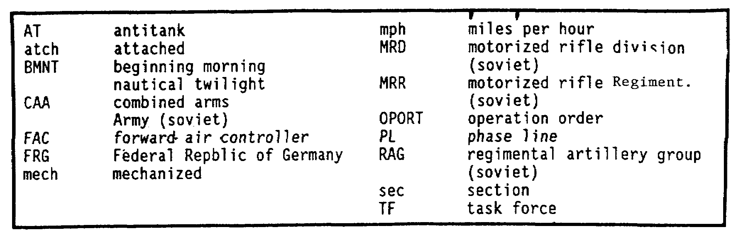

Figure 1.

(Classification)

Copy ___ of ___
TF 1-58 Mech
Burghaun (MV5529) FRG
092130 Apr 19__
1. TF 1-58 OPORD 6-__.

TASK ORGANIZATION

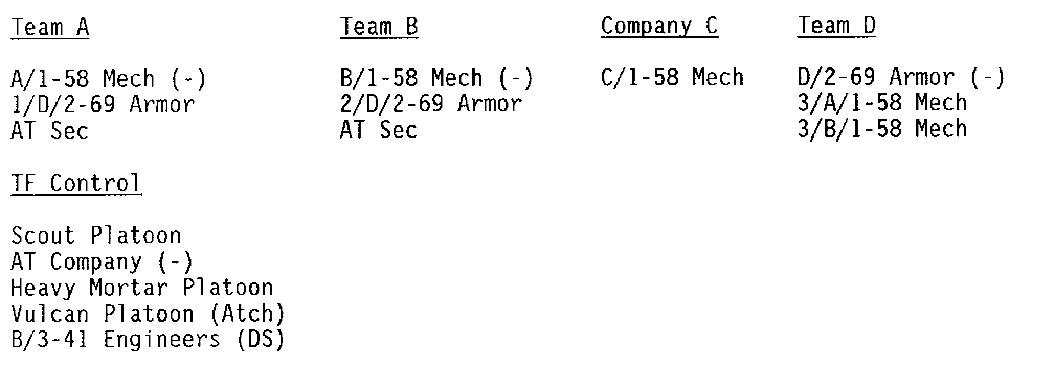

2. SITUATION.

a. Enemy Forces.

(1) Terrain and weather.

(a) Terrain. Key terrain in the TF sector are the hill masses at 4318, 4417, and 4315.

(b) Weather. Sixty percent chance of light rain or snow during daylight hours, decreasing to 30 percent at night. Wind 5 to 10 mph from the northwest. Average temperature will be around 45°. Dense fog is expected in low areas during the night. Visibility is expected to be about 2,000 to 3,500 meters during daylight. Cross-country mobility will be reduced because of soggy terrain. Beginning morning nautical twilight (BMNT) is 0505 and sunrise is at 0535.

(2) Enemy situation. TF 1-58 is opposed by elements of the 42d MRR, 33d MRD, of the 3d CAA. The enemy has established hasty defense positions along the 43/44 easting grid lines.

(3) Enemy capabilities. Enemy units are equipped with T-72 tanks, BMPs, and BRDMs. There is also a regimental artillery group (RAG) in the brigade sector. Currently, air parity exists.

(Classification)

(Classification)

b. Friendly forces. The 8th Mech Division conducts a deliberate attack at 190530 Apr 1986. The 197th Brigade attacks in the northern sector as a supporting attack for the division main effort. The 2d Brigade conducts the division main attack in the southern sector to seize their portion of the division objective.

3. MISSION. TF 1-58 will conduct a deliberate attack at 190530 Apr 19__ to secure task force Objective JOAN as part of 197th Brigade deliberate attack.

4. EXECUTION.

a. Concept of the operation.

(1) Maneuver. The TF attacks with three companies abreast. Team D attacks in the northern sector to secure Objective 325. Team A attacks in the secure Objective 369. Company C is the TF reserve.

(2) Fires. An on-call preparation is being planned by 1-4 FA (155-mm SP) to support the brigade attack. Priority of fires within the TF will go to Team A until Objective JOAN is secured.

b. Team A.

c. Team B. Coordinate with the scout platoon leader, as the platoon will be screening our south flank.

d. Company C. Follow in trace of Team A, and be prepared to assume the mission of any of the attacking teams.

e. Team D.

f. Scout platoon. Screen the southern flank of the TF sector. Coordinate with Team B.

g. Heavy mortar platoon. See paragraph h(3).

h. Fire support.

(1) Close air support.

(a) The battalion forward air controller (FAC) will be collocated with the TF commander in his command group.

(b) The TF is allocated 6 CAS sorties daily.

(Classification)

(Classification)

(2) Field artillery support.

(a) Priority of fires will go to Team A until Objective JOAN is secured. One priority target is allocated to Team A and one to Team D from Battery B, 1-4 FA.

(b) Organization for combat.

1-4 FA (155-mm, SP): DS 197th Bde
3-13 FA (155-mm, SP): R 1-4 FA

(3) Heavy mortar platoon. Priority of fires will go to Team A until securing Objective JOAN. Initial position for the platoon is vicinity 3716. Displacement forward will commence once teams are approaching phase line (PL) RED. Team A can plan for one priority target. 1st Section will be the control FDC, 2d Section will assume control on order.

i. Coordinating instructions. All teams report crossing Phase Line RED.

5. SERVICE SUPPORT (omitted).

6. COMMAND AND SIGNAL (omitted).

R. SMITH
LTC

Acknowledge:
/s/Jones
S3

(Classification)

SITUATION:

You have just returned from the TF briefing that was given at the tactical operations center (TOC). Your team commander has assembled his platoon leaders to issue his guidance. You are the company FSO for Team A, TF 1-58. Your target numbers are CC4200-CC4299. Additionally, the FSO has targeted five known enemy locations he received from intelligence sources.

CC4008 Platoon Position 437179
CC4009 Platoon Position 443164
CC4010 Platoon Position 438150
CC4011 Mortar Position 449153
CC4012 Company Position 471154

Team A commander's guidance to his company FSO is as follows:

“. . .Company FSO, I plan to use bounding overwatch using the checkpoints to control the movement of the platoons. In addition to the intelligence targets received from the FSO, I also just received word of an OP vicinity 413163. That is my first priority target. Ensure you obscure it if you can't destroy it. My second priority is the platoon position on Objective 358. Once we cross PL RED, it is imperative that the platoon be suppressed. Crossing the Fulda River is also of concern to me, so be prepared to screen our movement. Finally, once we secure the objective, we should be able to observe the enemy company position at 471154. Be prepared to control a CAS mission on that location. If you get any information on enemy air defense, plan to fire SEAD to support the CAS mission. Keep your plan simple, and coordinate with Team B and Company D FSOs to find out where they are going to plan their targets. That's all I have for now. I want to be briefed on your plan in 45 minutes. What are your questions?”

REQUIREMENT:

1. Given a map, an overlay, and the guidance provided, develop an offensive fire plan to support Team A. Plot and number all targets on the overlay, and transfer the relevant information to the target list work sheet provided.

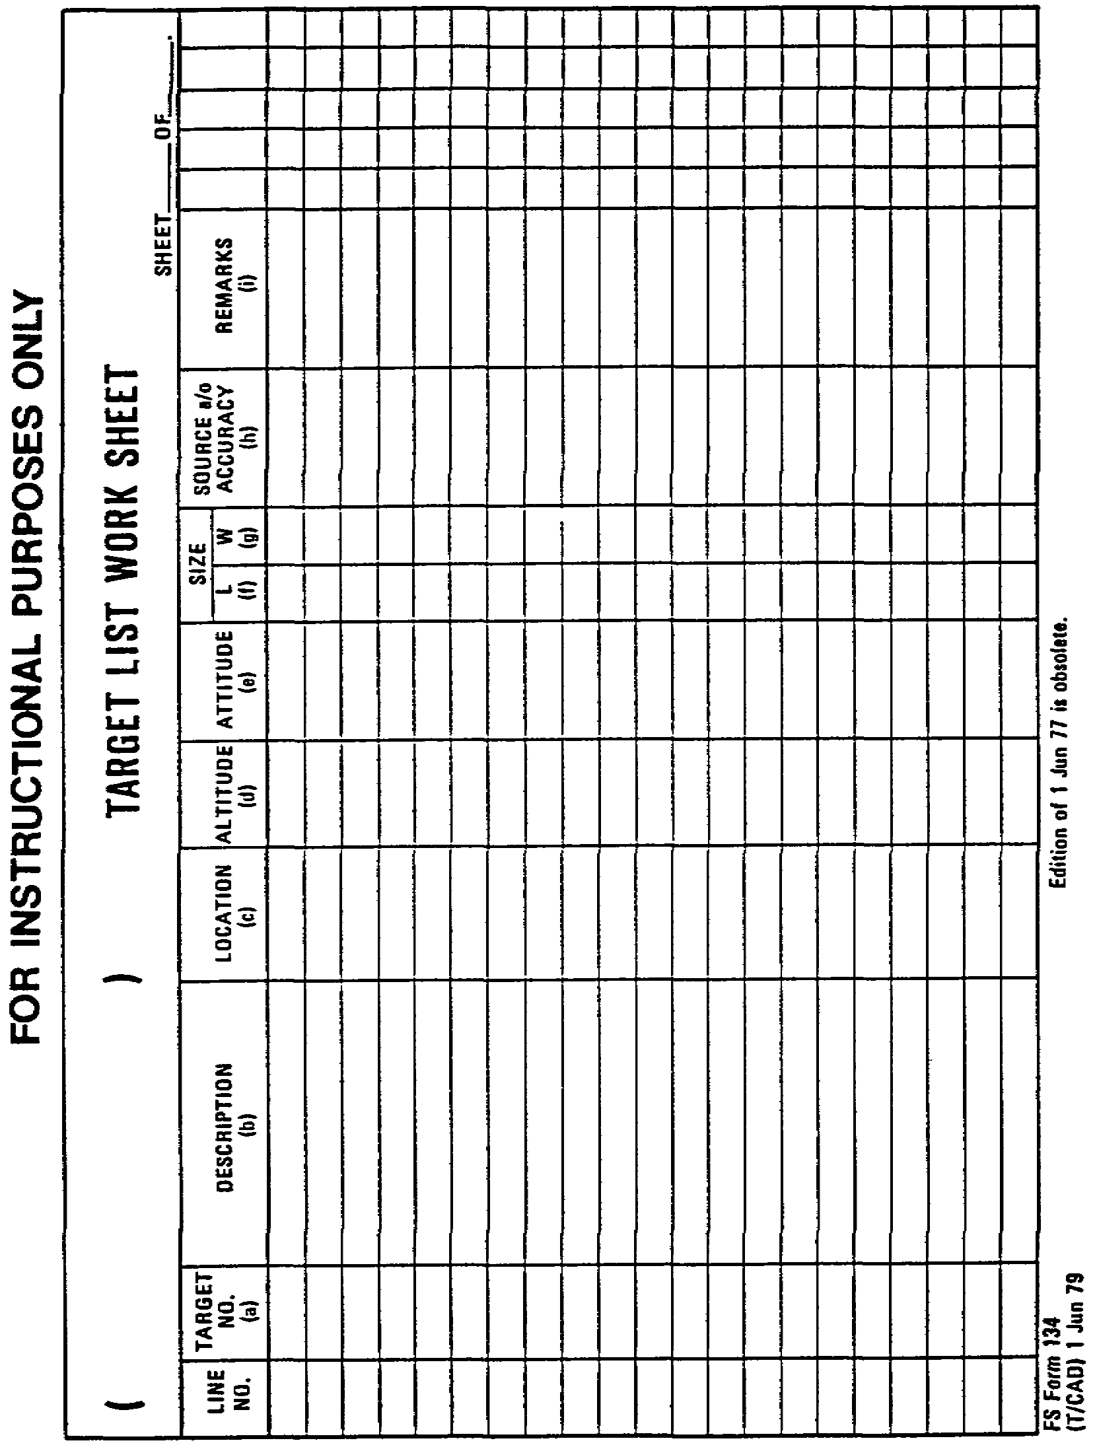

//////////////////////////////////////////////////////////////////////////////////////////////////////////////////////////////////////////////////////////////////

ANSWERS:

1. See completed target list work sheet.

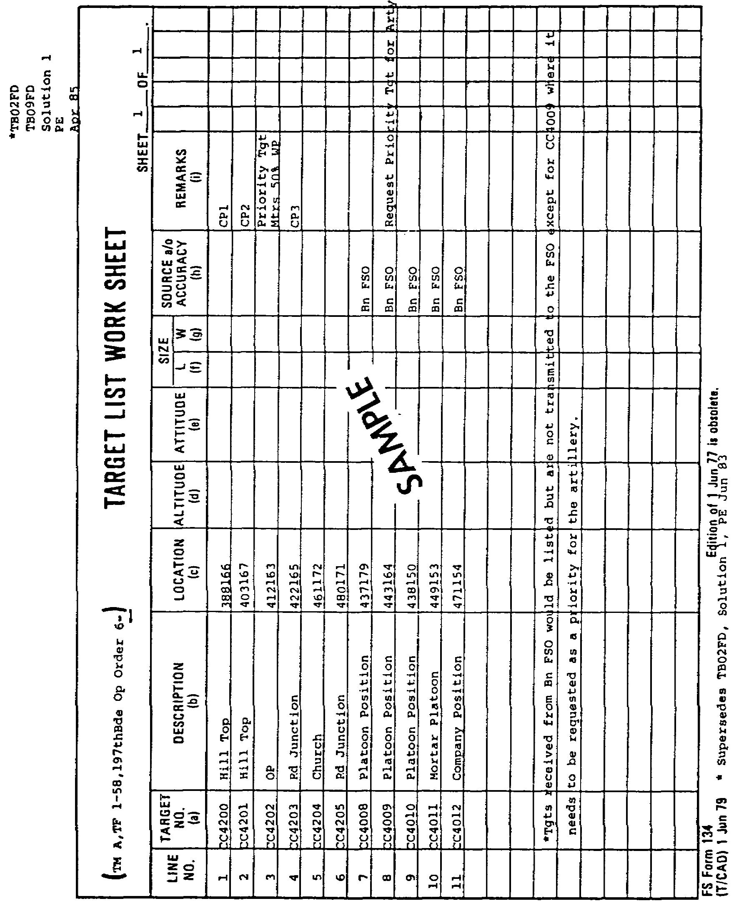

//////////////////////////////////////////////////////////////////////////////////////////////////////////////////////////////////////////////////////////////////

14. SUMMARY. Field artillery fire planning in support of offensive operations includes both the application of basic fire planning and additional considerations to support the maneuver force specific plan of attack. Once the momentum of the attack is gained, it must be maintained. The FSCOORD considers the fundamentals of the offense, applies sound tactics of supporting fires, and ensures that the maneuver forces have effective fire support throughout all phases of the attack. He considers the availability of ammunition, close air support, and other fire support means to accomplish the ultimate goal of an offensive operation--destroy the enemy.

Lesson 2
DEFENSIVE FIRE PLANNING

OBJECTIVE

Upon completion of this lesson, you will be able to apply fire planning considerations for defensive operations. You will also be able to state the primary reason for defending, to describe the defensive areas, and to describe the types of retrograde operations.

REFERENCES

This lesson is based on the current FM 6-20 series and other materials approved for US Army field artillery instruction. However, development and progress render the text continually subject to change. Therefore, base your examination answers on material presented in this text rather than on individual or unit experience.

15. INTRODUCTION. The immediate purpose of defensive operations is to defeat an enemy attack. All activities of the defense must contribute to that aim. The role of the fire support system is to support the maneuver forces in fighting a unified AirLand Battle. Other reasons to defend are as follows:

- Economize maneuver forces.

- Gain time.

- Wear down enemy forces to regain the offensive.

- Retain tactical, strategic, or political objectives.

- Control terrain.

- Preserve forces, facilities, or installations.

Defensive fires are planned on target locations within the battle area to limit enemy penetration of the defensive position, to neutralize or destroy enemy forces in the penetrated area, and to permit launching of a counterattack. Fire planning is centered at the DS battalion level. Augmentation fires are obtained from div arty GS and GSR units. Additional fires may be obtained from corps artillery.

16. FRAMEWORK. Fire support for defensive operations can be described in terms of a defensive framework described in FM 100-15. This framework shows corps and divisions using five complementary elements:

- Deep operations in the area well beyond the FLOT.

- Security force operations forward and to the flanks of the defending force.

- Defensive operations in the MBA.

- Reserve operations in support of the main defensive effort.

- Rear operations to retain freedom of action in the rear area.

a. Defensive fire support. Success in the defense depends on the careful planning and execution, as required, of fire support simultaneously into deep, close, and rear operations. Each of the five elements of the defensive framework must be considered when determining fire support requirements.

b. Allocation of fire support.

(1) As in the offense, corps and division commanders normally ensure adequate fire support for defensive operations by retaining some assets and allocating others to subordinate units. The four basic tasks of fire support provide the guiding principles:

- Support forces in contact.

- Support all aspects of the battle plan.

- Synchronize fire support.

- Support and sustain fire support.

(a) Support forces in contact. Supporting forces in contact usually means providing support for close operations. If done correctly, this task ensures the survivability of friendly forces and the freedom of maneuver. The various fire support assets support forces in contact in various time-tested roles and missions. The field artillery supports forces in contact in the defense by performing its traditional roles of close support, counterfire and interdiction. The Air Force operations of CAS and SEAD are specifically intended to support forces in contact, although BAI normally directly affects ground maneuver forces.

(b) Support the commander's battle plan. Supporting the force commander's battle plan means retaining sufficient assets for any possible contingency. Fire support assets for the rear and deep operations must be identified. Accomplishing this task gives the force commander the means to attack high-payoff targets whose destruction, neutralization, or suppression is necessary for overall mission success. The vagueness of the initial situation in the defense dictates that the force commander maintains more centralized control of his fire support. This is done initially by retaining more assets under his immediate control or by assigning FA units tactical missions that retain fire planning, priority of fires, and position authority at higher levels. This will ensure responsiveness by those units in massing and shifting of fires.

(c) Synchronize fire support. The synchronization of fire support at corps and division is essentially a command function. The FSCOORD is responsible for helping the commander integrate all fire support with the appropriate battlefield operating systems. A fire support synchronization methodology is
found in the decide-detect-deliver approach to targeting and battle management. The successful use of this
methodology enables the commander to attack the right target with the best weapon at the right time. This enables the force commander to take the initiative in selecting, locating, and attacking high-payoff targets.

(d) Support and sustain. Fire support for defensive operations must be sustained through all phases of the operation. Fire support systems must be survivable without degradation of availability.

(2) The allocation of specific fire support attack and acquisition systems will be conducted through the normal practices such as FA organization for combat. Assets will be allocated to--

- Provide deep fires to disrupt, delay, and destroy enemy follow-on forces before they can engage friendly forces.

- Provide counterfire to destroy, neutralize, or suppress the enemy's indirect-fire weapons.

- Provide SEAD to suppress enemy air defense weapons immediately before and during flight by friendly aircraft within the area of operations.

- Disorganize, delay, and disrupt critical enemy elements before the attack.

- Use both lethal and nonlethal attack means to apply constant pressure to the enemy's command and control structure.

- Acquire and attack high-payoff targets throughout the battlefield.

- Provide fire support synchronized with maneuver and command and control countermeasures in the conduct of deep operations.

- Retain centralized control of fire support resources to concentrate fire at the decisive place and time.

- Provide fires to support counterattacks.

17. SECURITY FORCES OPERATIONS FORWARD AND TO THE FLANKS OF THE DEFENDING FORCES.

a. Description. Within the AirLand Battle defensive framework, security forces perform one of two functions: screening or covering force operations.

(1) Screening force operations for the offense and defense are similar and require the same fire support considerations.

(2) Covering force operations in the defense differ from those in the offense in that an enemy attack is expected. Corps and division commanders plan to use the advantages of the defender to defeat the enemy. To exploit these advantages, the covering force must provide the force commander with a developed tactical situation that allows the MBA forces to establish and execute a successful defense. Specifically, the covering force occupies a sector far enough forward of the forward edge of the battle area (FEBA) to--

- Protect the MBA units from surprise.

- Allow the MBA forces time to prepare defensive positions.

- Prevent the delivery of enemy medium-range artillery fires against MBA units.

- Deceive the enemy as to the location of the main defensive positions.

- Defeat a specified size force or exact a specified percentage of damage of first echelon forces.

(a) The size and composition of the covering force and the covering force area depends on the mission, enemy, terrain, and available forces. Generally, the depth of a forward defensive covering force area should be extensive enough to force the enemy to reposition his artillery and air defense forces before his attack.

(b) The level of command for controlling covering forces depends on the width and depth of the area, communications capabilities, available control headquarters and the number of units in the covering force. Normally, corps and divisions control their own covering force operations. MBA brigade control of covering forces is less desirable as it takes away assets from the MBA, is difficult to control, and complicates reporting.

b. Fire support considerations.

(1) Fire support tasks. Fire support tasks for security are as follows:

- Engage the enemy early to strip away his reconnaissance elements. Specifically, these reconnaissance elements must not infiltrate and slip through the covering force. Early fires also will aid in forcing the enemy to deploy his attack formations.

- Assist maneuver in moving and disengaging.

- Provide SEAD to allow attack helicopters and Air Force aircraft to attack. Destroy air defense artillery (ADA) radars located by EW.

- Engage engineer mobility detachments to reduce the enemy's engineer mine-clearing capability before his arrival in the MBA.

- Mass fires that will delay, disrupt, or limit the enemy's advance.

- Integrate fire and obstacle plans, and ensure obstacles are covered by direct observation.

(2) Allocation of fire support. Security forces normally operate at considerable distances from their main force and possess only a minimum of maneuver combat power. Additional combat power must be provided to security forces in general and covering forces in particular through decentralization of fire support assets. Decentralized fire support provides the responsive fire power needed to--

- Make up for the lack of maneuver in relation to the large covering force area.

- Cause the enemy to deploy, thinking he has made contact with the MBA forces.

(a) The degree of decentralization depends largely on the amount of fire support available. Decentralization is achieved by assigning--

- One DS artillery battalion for each battalion-sized maneuver element in the covering force.

- Nonstandard tactical missions to MBA artillery units to make them responsive to the covering force artillery headquarters.

- The preponderance of other fire support assets to the covering force. For example, UAV, CAS, EW, AFSOs, and TACAIR reconnaissance assets must be responsive to the covering force.

(b) Considerations for allocating FA support to the covering force in the defense are similar to those of an offensive covering force discussed in Lesson 1. Specifically, three factors must be considered:

1. Attachment. Because covering forces may operate at great distances from the MBA forces, it may be very difficult to provide adequate support by only assigning a tactical mission. Problems of command and control may dictate a change to the normal command relationship. This is particularly true when covering forces are spread across a wide frontage or throughout a deep zone. The method of attachment depends on the control of the covering force. If the covering force is being controlled by the MBA headquarters, attachment of FA forces is not necessary. Normally, this is not the case and the covering force has a controlling headquarters of its own. Likewise, a covering force artillery headquarters must be designated.
This is often accomplished by attaching an FA brigade to the covering force. The FA headquarters then becomes the force artillery headquarters and the FA brigade commander is the FSCOORD for the covering force.

2. Representative caliber. Artillery supporting covering forces should represent those cannon and rocket systems supporting the MBA forces. This helps deceive the enemy as to the location of our MBA.

3. Mobility of fire support. The FA supporting covering forces must be as mobile as the force it supports.

NOTE: There will be times when all of these considerations cannot be met due to the availability of types or caliber of weapon systems. In these cases, planners must weigh the factors of METT-T against the overall goals of the maneuver commander's intent.

(3) Fire support planning and coordination.

(a) The keys to successful fire support planning for the defense, and particularly the covering force, are staff interactions throughout the targeting process and the correct application of IPB and TVA. (See FM 6-20-10.) Initial planning should be as detailed as possible to exploit the advantages the covering force has when operating over familiar terrain with prepared defenses. Since the enemy has the initiative, predictive planning for all courses of action must be accomplished. Once execution begins, flexibility through detailed contingency planning is required to allow response to the unexpected.

(b) Positioning of FA elements is a critical part of the detailed planning that must occur. A thin maneuver covering force may have to travel a greater distance to react to an enemy threat. Field artillery units may have to move laterally, forward, or to the rear to support the changing tactical situation. This requires detailed planning and rapid coordination on the part of the FSCOORD (FSO) and FA operations officer.

(c) Fire support coordinating measures in the covering force should be permissive in nature to open the battlefield to responsive fire support. This can be done by planning successive, on-order CFLs as close to friendly troops as possible.

(d) A crucial part of the covering force battle is planning, coordinating, and executing the battle hand-over. As the battle progresses, a rearward movement will occur eventually. Maneuver units and their FSCOORDs must ensure that needed information gets back to the MBA units. Items such as targets, targeting information, status of covering force units, ammunition status, and requirements for positioning must be current. Positioning information is particularly important if control of the battle is to be passed smoothly to the MBA force. Handing over the battle and the corresponding rearward passage of lines is a difficult
operation that requires a massive planning effort. One of the key elements of the battle hand-over is the
change of command and control of fire support. Control of indirect fires passes to the MBA force as the covering force hands over the battle. The hand-over is sequenced one sector at a time, until the entire security force has been withdrawn. Management of this operation is critical since the confusion of combat may cause some covering force units to pass through different units than originally planned. Detailed coordination between the passing and stationary force commanders and FSCOORDs is essential.

(e) Similarly, the assumption of on-order tactical missions by the passing force FA units will be difficult to manage. On-order missions must be carefully planned to facilitate the likely nonlinear battle hand-over.

(4) Sustainment. Execution of combat service support for security operations must be in concert with the overall operation. CSS must be coordinated with tactical operations in the rear and the MBA.

(a) Sustainment of security operations is a corps responsibility. When nondivisional units are given the mission, corps support command (COSCOM) assets directly support these units. When divisions conduct security operations with divisional assets, the corps sustains the division in its habitual manner.

(b) Only those CSS assets immediately essential to the operation should be positioned forward in the security area (fuel, ammunition, medical, and limited maintenance). These assets should be withdrawn when no longer required or the risk of their loss becomes unacceptable.

PRACTICE EXERCISES:

34. Screening force operations for the offense and defense are similar and require the _____ fire support considerations.

35. Covering force operations in the defense differ from those in the offense in that an enemy attack is expected. Corps and division commanders plan to use the _________ ____ ____ _________ to defeat the enemy.

36. Field artillery units may have to move __________, forward, or to the rear, to support the changing tactical situation.

//////////////////////////////////////////////////////////////////////////////////////////////////////////////////////////////////////////////////////////////////

ANSWERS:

34. same
35. advantages of the defender
36. laterally

//////////////////////////////////////////////////////////////////////////////////////////////////////////////////////////////////////////////////////////////////

18. MAIN BATTLE AREA DEFENSIVE FIRE SUPPORT PLANNING. The main battle area (MBA) extends from the FEBA back to the rear boundary of the brigade for the division and the rear boundary of the division for the corps. The bulk of the defending force normally is deployed in the MBA to defeat the enemy's main attack. Since the decisive defensive battle is often fought in the MBA, it is here where forces are concentrated. The mission of the MBA forces of the corps covers the entire spectrum of operations. Thus, while the corps as a whole may be engaged in defensive operations of the MBA, units within the corps area (divisions, brigades, and task forces) may well be conducting any or all of these operations:

- Defend--control a limited area or position.

- Delay--control an enemy.

- Attack--enemy or terrain oriented.

- Security and economy-of-force tasks.

- Forward and rear passage of lines.

- Movement to contact.

- Bypassed operations and/or encircled operations.

Thus, there will be differences in the way combat forces fight the defensive battle. Both heavy and light forces can conduct these operations. Task forces from the covering force join the MBA fight as they become available.

a. Fire support considerations. Fire support in the MBA is used to slow, stop, or destroy attacking forces. The enemy is detected early and attacked continuously with all available fire support means. Fires across the entire front force the enemy to deploy early into his attack formation. Fires in the economy of force areas are dense enough to slow or divert the enemy's supporting formations. When the attacker masses his forces, the defenders must attack those formations repeatedly and effectively with massed fires to reduce the enemy's momentum. Deep and/or interdiction fires against the attacker's follow-on forces keep them from influencing the immediate battle.

b. Fire support tasks. Fire support tasks in defense of the MBA are as follows:

- Mass fires to canalize and stall enemy forces, increase engagement, and destroy attacking elements.

- Isolate enemy first-echelon elements by attacking follow-on forces.

- Support friendly strongpoints.

- Support obstacles to slow breaching attempts.

- Suppress enemy air defenses.

- Help support rear operations by fire.

- Provide counterfires.

- Deny the enemy use of chosen avenues of approach.

- Suppress and obscure enemy overwatch positions.

- Force enemy armored vehicles to button up and slow down.

- Support counterattacks or conduct counterattacks by fire.

- Provide an economy of force measure that augments maneuver assets and frees them for other critical areas.

- Mass fires on enemy avenues of approach.

- Coordinate immediate close air support to engage major armored formations.

- Support disengagements of maneuver elements and repositioning to subsequent battle positions.

- Reinforce obstacles by use of FASCAM.

c. Allocation of fire support.

(1) Fire support for the MBA battle is allocated with priority to the most vulnerable area. Usually, this area coincides with the enemy's most likely avenues of approach and main attack. While fire support for the defense in general is most responsive when centrally controlled, the most vulnerable area of the MBA must be weighted more heavily with immediately responsive fires. Reinforcing field artillery, immediate CAS sorties, EW, and targeting assets can be used to provide responsive support to forces bearing the brunt of the enemy's attack.

(2) Fire support for the MBA must be allocated as early in the estimate process as possible to allow commanders sufficient planning time. The proper integration of IPB and TVA provides commanders with the "best guess" of likely enemy courses of action. This analysis is then used to prepare contingencies for the main battle. The covering force will develop the situation and dictate which contingency should be executed. Appropriate fire support must be allocated for each of these possible contingencies. As much fire support as possible should be centrally controlled to facilitate a rapid and smooth transition into any contingency plan. Fire support under centralized control allows the force commander to rapidly shift combat power without moving maneuver forces.

d. Positioning of field artillery.

(1) Initially, FA units may be positioned in forward supplementary positions in the MBA to allow for deeper fires. Supplementary positions should be--

- Along routes that facilitate displacements into the MBA.

- Selected to provide good cover and concealment to minimize their vulnerability to enemy air attack.

(2) As the battle develops, FA units may find themselves astride an enemy route of advance. When possible, these units should be repositioned along the flanks or deeper in the MBA. This gives maneuver forces room to operate and reduces untimely displacements during the battle. Positions selected must be coordinated with the maneuver commander responsible for the terrain. (See FM 6-20-2, Division Artillery, Field Artillery Brigade, and Field Artillery Section [Corps].)

e. Target acquisition.

(1) The key to good combat information is knowing how the enemy will attack and knowing what to expect. For corps and divisions, FSCOORDs and their staffs are excellent information sources. Also, the field artillery has excellent combat communications by which to transfer this needed information.

(2) In the MBA, radars should be focused on the enemy's main effort. This is where the enemy can be expected to concentrate his indirect fire weapons. Weapons-locating radars should be positioned to maximize lateral coverage immediately forward of the MBA.

(3) As MBA forces are repositioned to meet an enemy main effort, target acquisition elements also should be repositioned. Displacement of these resources should be staggered so that some coverage is always available.

(4) AFSOs can provide target acquisition (TA) and can cue other TA systems. The AFSO also can hand off and designate targets for Army aviation and Air Force attack.

f. Communications.

(1) The handoff of the battle from covering forces to MBA forces is a critical point in the defense. Effective command and control is especially important to ensure a smooth changeover and continuous and effective fire support. Communications must be established between MBA and covering forces before control of the battle changes. This is best achieved when MBA force artillery monitors the nets used by covering force artillery before the battle hand-over.

(2) Radio communications should preclude the following:

- Covering force artillery having to change frequencies at a critical time.

- Issuing additional SOI extracts to units in the covering force. This reduces the possibility of SOI compromise.

- Early use of the MBA nets and possible detection by enemy jammers or direction-finding equipment before the MBA fight.

g. Suppression of enemy air defenses.

(1) The heavy use of friendly aircraft may be needed during combat operations. Enemy air defenses must be suppressed to let friendly aircraft operate in the airspace above or near enemy air defenses and their associated equipment and facilities. This requires a coordinated effort between air and land elements to locate enemy facilities and to plan and execute SEAD operations with all available lethal and nonlethal means. Usually, the land force management of SEAD fires is centered at the division main fire support element; however, SEAD can be planned, managed, and executed at all echelons.

(2) Normally, SEAD planning is done at the division main fire support element or below. Targets of concern to the air elements are processed here and assigned to appropriate fire support or EW agencies.

(3) Because fire support is limited, the force commander must indicate his priority for SEAD targets. The FSCOORDs plan accordingly.

(4) Individual requests by flight leaders (pilots) for SEAD support are treated as targets of opportunity (immediate targets).

h. Counterpreparation fires. Counterpreparation fires may be used if the maneuver commander desires. Counterpreparation fires are designed to break up enemy preparations for the attack and the continuity of his attacking elements. Acquisition resources and targeting efforts are directed toward detecting enemy forward elements, indirect fire support means, observation posts, command posts, and reserves. Counterpreparations are fired when the enemy attack is imminent.

i. Nuclear planning. The corps commander has the principal responsibility for operational planning and execution of nuclear fires. The corps commander develops and issues his planning guidance. The planning effort must then be focused on these contingencies and developed into the corps nuclear package. The package contains division subpackages that include nuclear fires delivered by the division artillery, Air Force, and supporting FA brigade. The corps main FS cell must know the status of all nuclear-capable delivery units.

PRACTICE EXERCISES:

37. Fire support in the MBA is used to slow, stop, or _____________ attacking forces.

38. Initially, FA units may be positioned in ___________ ___________ positions in the main battle area to allow for deeper fires.

39. Fires in the economy of force areas are dense enough to slow or ___________ his supporting formations.

//////////////////////////////////////////////////////////////////////////////////////////////////////////////////////////////////////////////////////////////////

ANSWERS:

37. destroy
38. forward supplementary
39. divert

//////////////////////////////////////////////////////////////////////////////////////////////////////////////////////////////////////////////////////////////////

19. DEEP BATTLE AREA DEFENSIVE FIRE SUPPORT PLANNING.

a. Description. Deep operations begin before the enemy closes with the corps or division and continue throughout the battle. Deep operations are used to effect closure times of follow-on elements and to create windows of opportunity for destructive actions against them. A successful deep operation may cause the enemy commander to alter his attack plan because it disrupts his flow of echelons as they move toward the FLOT.

b. Allocation. The allocation of fire support assets for deep operations will be made by determining the friendly area of greatest vulnerability, and predicting where the enemy will conduct his main attack. Specific considerations include the following:

- The provision of adequate fire support to achieve operational objectives.

- The destruction of high-payoff targets in enemy's follow-on forces.

- The delivery of SEAD to support tactical air support.

- The potential use of Army aviation as a means of providing deep fires.

- The use of AFSOs to facilitate fire support coordination and execution during operations.

- The use of chemical weapons (when use of these weapons has been approved) to delay enemy follow-on forces, disrupt C², and deny critical facilities and assets.

- The use of nuclear fires (when use of these weapons has been approved by proper authority) to destroy enemy follow-on forces, C2 facilities, and other high-value targets such as surface-to-surface missiles.

c. Targeting. The decide-detect-deliver targeting methodology will be used to plan and execute fire support for deep operations in a defensive situation, just as it is used for the offense.

PRACTICE EXERCISES:

40. Deep operations begin ________ the enemy closes with the corps or division and continue throughout the battle.

41. The allocation of fire support assets for deep operations will be made by determining the friendly area of greatest vulnerability, and predicting where the enemy will conduct his ______ attack.

//////////////////////////////////////////////////////////////////////////////////////////////////////////////////////////////////////////////////////////////////

ANSWERS:

40. before
41. main

//////////////////////////////////////////////////////////////////////////////////////////////////////////////////////////////////////////////////////////////////

20. RESERVE OPERATIONS FIRE SUPPORT PLANNING.

a. General.

(1) The primary purpose of reserves in the defense is to preserve the commander's flexibility. The reserve is the commander's principal means of providing decisive support to a battle in progress or affecting future operations. Commanders should decide the mission, composition, and size of the reserve based on their estimate of the situation.

(2) Reserves may be air or ground maneuver units. When the reserve is committed, all available fire support will be used to support it. The committed reserve becomes the main effort of the commander and all combat power is concentrated there by the force.

(3) In the mobile defense, the reserve is relied upon to strike the decisive blow. When conditions favoring counterattack occur, the main effort shifts to the reserve, which then strikes with overwhelming combat power. The FSCOORD assists by integrating the available fire support.

(4) Commanders can use reserves to--

- Counterattack to exploit enemy vulnerabilities (flanks, support units, and unprotected forces in depth).

- Reinforce forward positions.

- Block penetrating enemy forces.

- React to rear area threat.

b. Fire support considerations. Fire support tasks for reserves are as follows:

- Plan fires to support the commitment of the reserve during movement.

- Plan fires to strike at objectives in depth as enemy dispositions are revealed to support the committed reserves and break up the enemy's coordination of the attack in the area defense.

- Plan fires on the enemy's flanks and rear where counterattacking forces are committed in the mobile defense.

- Plan deceptive fires to deceive the enemy into thinking the reserve is committed elsewhere.

- Plan for fire support coordinating measures such as a restrictive fire line in case of converging forces in the mobile defense or a restrictive fire area to provide safeguards for strongpoints in the area defense.

- Plan to rearm, refit, and refuel organic and supporting fire support before assuming on-order missions.

c. Allocation. In organizing the artillery for combat and in the allocation process of other fire support, consideration must be given to the following:

- A plan for the use of fire support organic or habitually supporting the reserve force until it is committed.

- Providing adequate support to the force at the time of commitment.

- Factors of METT-T.

- Commander's estimate of the situation.

- Commander's intent.

(1) As in the offense, missions of GS or GSR are best for artillery units designated to support reserves once committed for the reasons previously mentioned.

(2) Once the reserve is committed, organic and habitually supporting field artillery is augmented by other lethal and nonlethal fire support. Nuclear weapons also may be considered as reserves and set aside for eventual commitment if their use has been approved by proper authority.

(3) Unnecessary changes in organization and time-consuming movements should be avoided to ensure adequate support for the committed reserve. Timely fire support planning will ensure timely support. The use of
an FA brigade headquarters as a fire support planning agency for the counterattacking force should be considered, thereby freeing the division artillery of this task.

PRACTICE EXERCISES:

42. The ___________ is the commander's principal means of deciding a battle in progress or to affect future operations.

43. Once the reserve is committed, organic and habitually supporting field artillery is ___________ by other lethal and nonlethal fire support.

44. Timely fire support planning will ensure ___________ ___________.

//////////////////////////////////////////////////////////////////////////////////////////////////////////////////////////////////////////////////////////////////

ANSWERS:

42. reserve
43. augmented
44. timely support.

//////////////////////////////////////////////////////////////////////////////////////////////////////////////////////////////////////////////////////////////////

21. REAR AREA DEFENSIVE FIRE SUPPORT PLANNING.

a. General. Rear operations with the corps or division in a defensive posture requires increased vigilance against the more pronounced threat to our rear area. Rear operations are situational and planned for as a contingency. They are waged as the need arises and with the intensity necessary to meet the threat level. Attempts to disrupt or destroy command and control, combat support, and combat service support activities can be expected. Operations in the corps rear must be planned to deal with Levels I, II, and III threats.

b. Fire support considerations.

(1) Allocation.

(a) Combat support and CSS units in the corps rear do not have the capability to defeat Level III threat forces. They are capable of fighting self-defense actions pending reinforcement or relief. The commander must allocate combat forces to defeat Level III threats.

(b) This TCF is normally a brigade equivalent at corps and a battalion equivalent at division. The size is based on the most probable threat to the corps rear being an airborne and/or air assault regiment. Fire support for the TCF should be provided for by an on-order DS mission for an artillery unit. This requires the force artillery to position units in anticipation of that requirement. Other fire support means include CAS, naval gunfire, Air Force special operations, and Army aviation.

(2) Targeting. The enemy is capable of inserting airborne and/or air assault units of regimental size or larger into the rear area at any time. The G2 must conduct rear area IPB, collect intelligence, and
maintain surveillance of the rear at all times. Key collection sources in the rear area are human intelligence (HUMINT) assets, to include the local population. Additional collection assets must be allocated to rear operations. Analysis of enemy maneuver must be relayed to the rear CP. Surveillance and reconnaissance operations by MPs, base clusters, aviation and air defense elements provide information while conducting normal missions. AFSOs may be used to augment rear targeting assets.

(3) Sustainment. A significant concern in rear operations is the potential interruption of lines of communication and possible destruction of CSS units and stocks. Sustainment during rear operations involves support of those forces responding to the rear threat, as well as continued sustainment of the corps close and deep battle. Sustainment plans must allow for contingencies, damage control, and recovery from attack.

PRACTICE EXERCISES:

45. Operations in the corps rear must be planned to deal with levels ___, ___, and ___ threats.

46. Other fire support means include CAS, ___________ ____________, Air Force special operations, and Army aviation.

47. Sustainment during rear operations involves support of those forces responding to the __________ ____________, as well as continued sustainment of the corps close and deep battle.

///////////////////////////////////////////////////////////////////////////////////////////////////////////////////////////////////////////////////////

ANSWERS:

45. I, II, III
46. naval gunfire
47. rear threat

///////////////////////////////////////////////////////////////////////////////////////////////////////////////////////////////////////////////////////

22. FIELD ARTILLERY POSITION SELECTION AND DISPLACEMENT. Field artillery units should be positioned far enough forward to support the deep battle and engage targets acquired through acquisition means. Primary and alternate positions must be preselected to allow survey and prepositioning of ammunition. Positions and routes must be coordinated with the maneuver forces. Repositioning and displacements must be planned to provide continuous support and not conflict with maneuver operations. Survivability of FA units can be enhanced by positioning in depth and repositioning out of the path of the enemy main effort. Priority of position is given to units providing close support for maneuver elements in the security area (SA) and MBA. First priority goes to FA units with a DS mission, followed by those with a reinforcing mission. The overriding criterion is that the position area selected enable that unit to cover effectively the zone of fire inherent in its assigned mission.

23. AMMUNITION MANAGEMENT. Ammunition requirements directly influence tactical operations and are controlled by each tactical commander. A division preparing to defend may pre-position conventional ammunition. Ammunition to support unforeseen requirements such as counterpreparations may be drawn as ammunition for immediate consumption. A commander deciding to pre-position ammunition must consider the risk of losing that ammunition should the enemy penetrate the defensive position. Factors influencing the RSR in a defensive operation include the following:

- Planning for counterpreparation fires.

- Estimating fire support requirements for a counterattack.

Estimates for ammunition requirements are usually based on FM 101-10-1, experience, or historical data. Ammunition management was discussed in Lesson 1 of this subcourse.

SELF-EVALUATION:

NOTE: The following is the OPORD to be used for this exercise. Figure 2 lists the acronyms and abbreviations in the following OPORD.

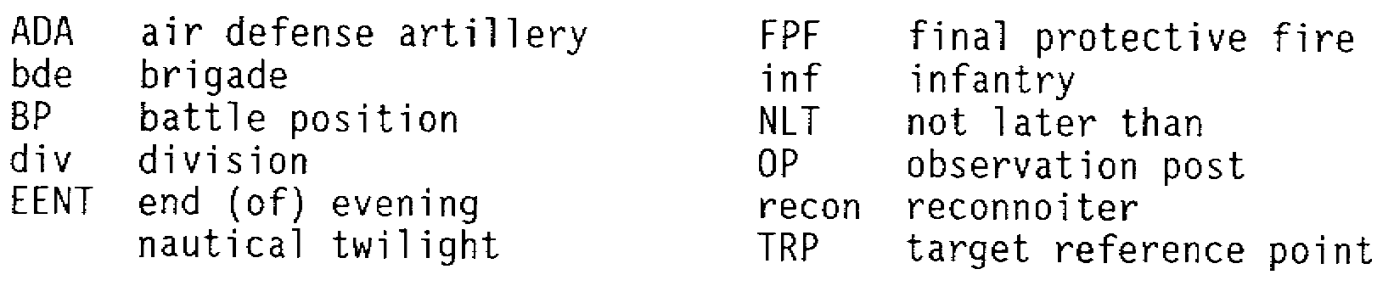

Figure 2.

(Classification)

Copy _____ of _____
TF 1-58 Mech Infantry
Burghaun (MV5529) FRG
181600 May 19__
1. TF 1-58 OPORD 5-____.

Reference: Map Series M164, FRG, Sheet L7619 (BURGHAUN), Edition-I-BER, 1:50,000.

Time Zone Used: Zulu.

TASK ORGANIZATION

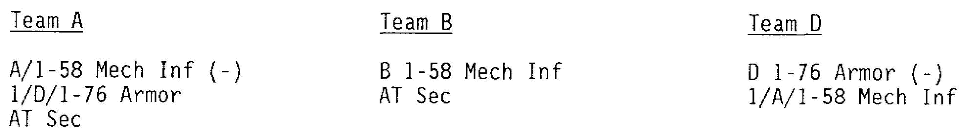

(Classification)

(Classification)

TF CONTROL

Scout Platoon
AT Company (-)
Heavy Mortar Platoon
Vulcan Platoon (Atch)
B/3-41 Engineers (DS)

2. SITUATION.

a. Enemy forces.

(1) Terrain and weather.

(a) Terrain. Key terrain in the TF sector are the hill masses at 4714, 4917, and 4416.

(b) Weather. Sixty percent change of light rain or snow during daylight hours, decreasing to 30 percent at night. Wind 5 to 10 mph from the north-northwest. Average temperature 40°. Dense fog is expected in low areas during the night. Visibility is expected to be approximately 1,500 to 3,000 meters during daylight. Cross-country mobility will be reduced because of soggy terrain. BMNT is 0445 and EENT is 1945.

(2) Enemy situation. TF 1-58 is opposed by the 42nd MRR, 33rd MRD, and 3d CAA. The enemy has made limited contact with the covering force units.

(3) Enemy capabilities. Enemy units are equipped with T-72 tanks, BMPs, and BRDMs. Additionally, they have a organic engineer and air defense artillery (ADA) equipment. They currently have air superiority.

b. Friendly forces. 8th Mech Inf Div defends in sector 182100 May 19__. 1st Bde defends in sector 182100 May 19_ with TF 3-7 (north), TF 1-58 (center) and TF 2-69 (south).

3. MISSION. TF 1-58 defends in section 182100 May 19__ to retain the village of Langenschwarz (4418) and prevent penetration of the battalion TF rear boundary.

EXECUTION.

a. Concept of the operation.

(1) Maneuver. Team A occupy BP 1; recon, and prepare BP 4. Company B occupy BP 2; recon and prepare BP 5. Team D occupy BP 3; recon and prepare BP 6.

(Classification)

(Classification)

(2) Fires. An on-call counterpreparation is being planned by 1-3 FA (155, SP) to support the brigades defense. Priority of fires will initially go to the scout platoon and, on order, shift to Company B.

(3) Obstacles. The FSO, engineer platoon leader, and S3 have designated two scatterable minefield aimpoints. These will reinforce the obstacle/barrier plan.

b. Team A. Help the scouts with the passage of lines; coordinate with the scout platoon leader NLT 182000 May 19__.

c. Company B.

d. Team D.

e. Scout platoon. Establish a forward OP vicinity 502138. After passage of lines, screen TF north flank.

f. Heavy mortar platoon. See paragraph 4g(3).

g. Fire support.

(1) Air support.

(a) The FAC will be Company B initially.

(b) The TF is allocated 3 CAS sorties daily.

(2) Field artillery support.

(a) Priority of fires will initially be to the scout platoon. Upon their passage of lines, the priority will shift to Company B. One 155-mm FPF is allocated to Company B to keep reinforcements from closing.

(b) Organization for combat.

1-3 FA (155, SP) DS 1st Bde
3-12 FA (155, SP) R 1-3 FA

(3) Heavy mortar platoon. Priority of fires will initially be to the scout platoon. Upon their passage of lines, the priority will shift to Team A. Initial position will be vicinity 4718. One FPF will be provided to Team A. 1st section will be control FDC; 2d section will assume control on order. Mortar platoon leader will be at 1st section; platoon sergeant with 2d section.

(Classification)

(Classification)

(4) Coordinating instructions. A brigade CFL runs from 534185 across the TF front to 508110, effective on order.

h. Coordinating instructions. All units report departure from initial BP and arrival at final BP.

5. SERVICE SUPPORT (omitted).

Acknowledge:

R. GOATMAN
LTC

/s/Jones
S3

(Classification)

SITUATION: You have just returned from the TF OPORD briefing, which was given at the TOC. Your team commander has assembled his platoon leaders to issue his warning order and put out his planning guidance. You are the FSO for Company "B." (Target numbers CA3300-3399).

Company B commander's warning order and guidance:

“. . .Fire support officer, I want you to plan fires to support our defense of BP 2; additionally, plan fires to support our move back to BP 5, where we will defend to retain. Ensure smoke is planned to screen our movement as well. In BP 2, we will be oriented on the southern end of engagement area BLUE. My TRP is some old ruins at 499157. Apparently, I have an artillery FPF, so I would like to plan one on both BPs; and if we don't need it on BP 2, we can shift it back to BP 5. The dead space on BP2 I want covered is from 488157 to 492158. Once we move back to BP 5, we will orient on the middle section of engagement area RED. My TRP will be a lone house at 454169. The dead space we have identified is from 443161 to 444165. The scout platoon reports a couple of possible enemy OPs vicinity 502110 and 541132, so we had better watch out for those. That's all I have for now. I want to be briefed on your plan in 30 minutes. Do you have any questions?"

REQUIREMENT:

2. Given a map, an overlay, and the guidance provided, plot and label all targets required to support the commander's scheme of maneuver, and transfer the relevant information to the target list work sheet provided.

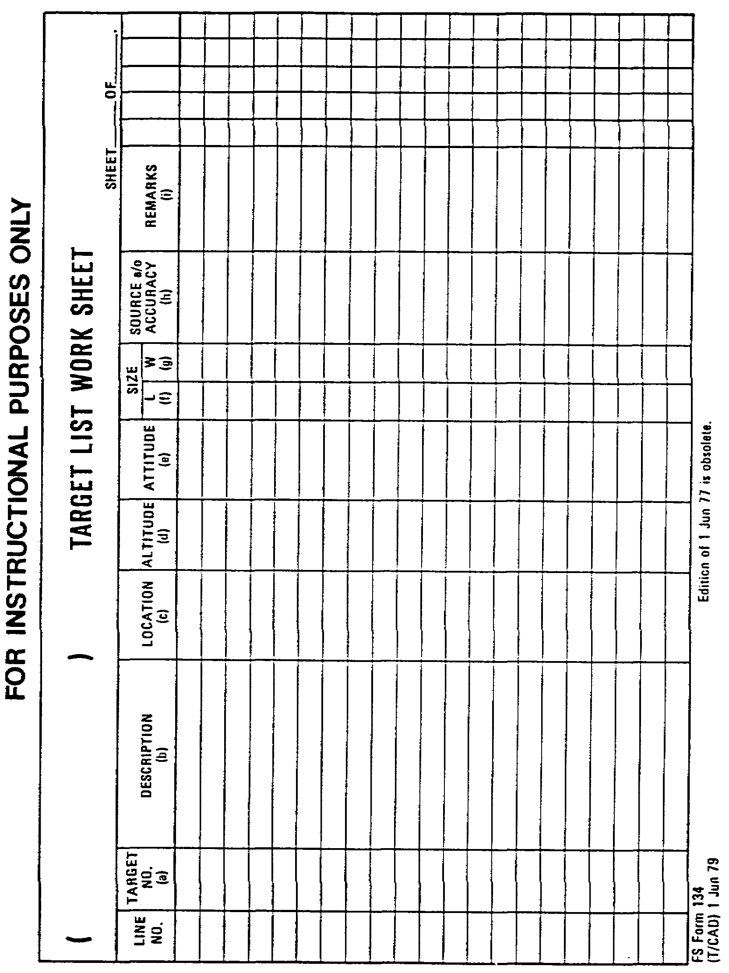

//////////////////////////////////////////////////////////////////////////////////////////////////////////////////////////////////////////////////////////////////

ANSWERS:

2. See the completed target list work sheet below.

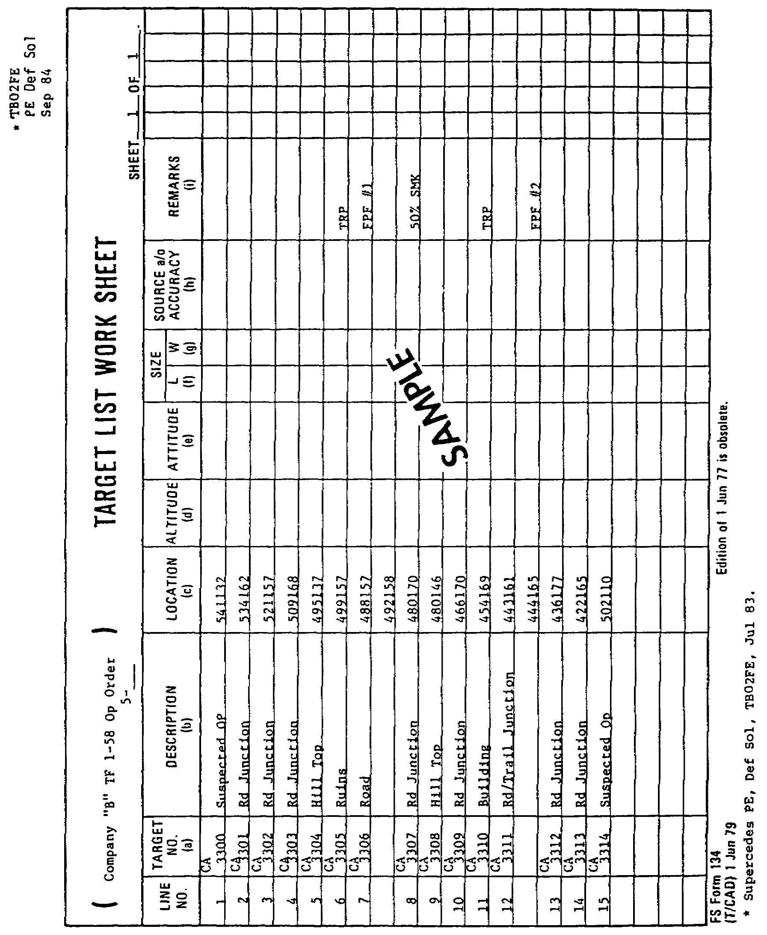

//////////////////////////////////////////////////////////////////////////////////////////////////////////////////////////////////////////////////////////////////

24. SUMMARY. The purpose of fire planning is to get the maximum effect from fires that are available to the force. Maneuver forces on the AirLand battlefield will always be faced with the threat of immediate attack or the requirement to mount an attack. Maneuver commanders are continuously planning to engage in either type of operation--offensive or defensive. The maneuver commander relies on his FSCOORD to plan fires to support the scheme of maneuver. This planning process will continue throughout the operation of whatever duration and will end only when the conflict has been brought to a successful close. A key to winning the defensive battle is to maximize the effect of all firepower available. Defensive operations are only a prelude to offense.

